NOT A POLLING PLACE
This location is no longer a polling place

Your new polling place is:
Polling place name
Polling place address line 1
Polling place address line 2
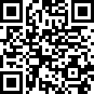
Polls are open from 7 a.m. – 8 p.m.

For more information, visit:
mnvotes.gov/pollfinder

Scan this code to visit mnvotes.gov and
find information about your polling place
Or call County Elections Office
(XXX) XXX-XXXX

