2022
State of Minnesota
ELECTION JUDGE GUIDE
Office of the Minnesota Secretary of State
180 State Office Building
100 Rev. Dr. Martin Luther King Jr. Blvd.
St. Paul, MN 55155
Phone: (651) 215-1440
Toll Free: 1-877-600-8683
Minnesota Relay Service: 1-800-627-3529
Email: elections.dept@state.mn.us
Website: https://www.sos.state.mn.us/

Contents
Election Judge Overview 1
About This Guide 1
Follow Local Instructions 1
Bring Your Guide to the Polls 1
Basic Qualifications 1
Student Election Judge Trainees 2
Training & Certification 2
Polling Place Assignments 2
Number of Election Judges per Precinct 2
Position Descriptions 3
Professional Conduct Expectations 4
Election Judge’s Oath 4
Code of Conduct 4
Preparing for Election Day 5
Election Emergency Plans 5
Time Off from Work 5
Appropriate Attire 5
Breaks & Meals 6
Remember to Vote 6
Before Leaving Home 6
Setting Up the Polling Place 7
General Advice for Polling Place Setup 7
Security Practices 7
Posting Signs & Directions 8
Name Tags 9
Set Up Stations 9
Equipment Setup 11
Preparing Ballots 13
Opening the Polls 13
Greeter Judge 15
Roster Judge 16
Checking in Pre-Registered Voters 16
Voter Receipts 16
Roster Troubleshooting Tips 17
Tips for Locating a Name 17
Keep the Roster Accurate & Orderly 18
Roster Data is Confidential 18
Roster Notations 19
Roster Challenge Procedure 20
Registration Judge 22
Voter Eligibility 22
Registration Steps 22
Proofs of Residence 23
Completing the “Election Judge Official Use Only” Section 25
Using the Precinct Finder 26
Common Residence Questions 27
Roster Data is Confidential 27
Address Confidentiality 27
Demonstration Judge 28
Voter Instructions 28
Additional Instructions for Primaries 28
Additional General Election Instructions 29
Constitutional Amendment Instructions 29
Ballot Question Instructions 29
Special Elections 29
Ballot Judge 30
Counting & Initialing Ballots 30
Ballot Shortages—Unofficial Ballots 30
Issuing Ballots 31
Spoiled & Found Ballots 31
Ballot Marking Device 32
Features 32
Types of Ballot Marking Devices 32
Ballot Counter Judge 34
Guidelines for Conduct 34
Assisting with Ballot Errors 34
Full Ballot Box Procedure 35
Troubleshooting a Jammed Ballot 35
If Ballot Counter Stops Working 35
Rules for Polling Place Conduct 36
Persons Allowed in or Near the Polling Place 36
Prohibition on Campaigning 36
Additional Prohibited Conduct 37
Voter Complaints 37
Providing Assistance to Voters 38
Assistance by Election Judges 38
Assistance from Others 38
Curbside Voting 38
Serving Voters Who Have a Disability 39
Voters Who Are Blind or Have Low-Vision 39
Voters Who Are Deaf or Hard of Hearing 39
Voters with Cognitive Impairments 40
Contesting a Voter’s Eligibility 41
Appointed Challengers 41
Code of Conduct for Appointed Challengers 41
Procedure for Making a Challenge 41
Refusing or Failing a Challenge 42
Closing the Polls Overview 43
Closing Activities Vary by Ballot Counting Method 43
Closing with Precinct Ballot Counter 44
Summary Statement & the Results Tape 44
Closing Procedures 44
Completing the Summary Statement 45
Process for Duplicating Ballots 46
Delivering Election Returns 46
Closing with a Central Ballot Count 47
Procedures at Polling Place 47
At the Counting Center 47
Hand-Count Precincts 49
Opening Procedures 49
Closing the Polls 49
Determining Voter Intent 50
Counting the Votes 51
Completing Summary Statements 52
Delivering Election Returns 52
Head Judge 53
Emergency Preparedness 53
Change of Polling Place 53
Replacing an Absent Judge 53
Emergency Judge Training 53
Emergency Voting Procedure 53
Incident Log 54
Absentee Ballots 54
Health Care Facility Judges 55
“Election Day” Health Care Facility Voting 55
Appendix 56
Head Judge Duties Checklist 56
Opening 56
Ballot Box Opening 56
Ballot Counter & Ballot Marking Station Setup 56
Open Polls 57
Close Polls 57
Closing with a Ballot Counter 57
Central Count Closing Procedures 57
Voters’ Bill of Rights 58
Voter Registration Application 59
Voucher Form 60
Guide for Registration Application 61
Required Sections 61
Complete if Applicable/Possible 61
Precinct List of Persons Vouching 62
Voting Residence Laws 64
Oath of Challenge to Eligibility 65
Certificate of Registered Voter 66
Precinct Summary Statement 67
HAVA Elections Complaint Form 69
State Election Law Complaint Form 71
Important Contact Information 74

Election Judge Overview

About This Guide
This guide is a reference for election judges on Election Day. Most sections have endnote citations in the back of the guide referencing election laws (Minnesota Statutes or M.S. citations) or election rules (Minnesota Rules or M.R. citations). Find the full text of election laws and rules at the Election Laws webpage on the Secretary of State’s website (https://www.sos.state.mn.us/election-administration-campaigns/election-administration/election-laws/).
The election process involves a sequence of required tasks. For this reason, the guide’s organization is by specific tasks performed on Election Day. Your local election official may provide you with additional instructions and forms.
Thank you for serving as an Election Judge!

Follow Local Instructions
Elections are administered by local jurisdictions. While all jurisdictions follow the same set of election laws, tasks can be accomplished in more than one way. You may find that the step-by-step instructions in this guide vary from those provided by your local official—when in doubt, follow the instructions provided by your local official, or call your local official for clarification as needed.

Bring Your Guide to the Polls
You are not required to memorize all the details of election procedure, but you are expected to be knowledgeable. Review this guide before Election Day and bring it with you to the polls. You can also download a copy directly from the Election Guides webpage on the Secretary of State’s website (https://www.sos.state.mn.us/election-administration-campaigns/election-administration/election-guides/)

Basic Qualifications
To serve as an election judge, you must be eligible to vote in Minnesota and be able to read, write, and speak English.

Restrictions
- Candidates for office cannot be an election judge in a precinct where they appear on the ballot. This includes those who are actively campaigning as a write-in candidate.
- A person who is a relative of a candidate for office cannot serve in a precinct where that candidate is on the ballot. Relatives include a spouse, parent, child, stepchild, brother, sister, stepbrother, or stepsister.
- A person who temporarily or permanently lives in the same house as a candidate cannot serve in a precinct where that candidate is on the ballot.
- Election judges who are relatives to each other cannot serve together in the same precinct during the same shift. Relatives include a spouse, parent, child, stepchild, brother, sister, stepbrother, or stepsister. Relatives can work separate, non-overlapping shifts in the same precinct.
- A challenger appointed to contest voter eligibility cannot serve as an election judge.
Related statutes or rules: M.S. 204B.19; 204C.07, subd. 4

Student Election Judge Trainees
Students, ages 16 and 17, can be election judge trainees. To serve, students must be a U.S. citizen in good academic standing at a Minnesota high school (or home schooled). They must also obtain school and parental permission and serve in the county where they reside or in an adjacent county. Trainees are paid at least two-thirds of the minimum wage. Like other judges, they do not have to serve the entire day; they cannot work past 10 p.m.
Trainees are assigned the same duties as other judges, except for tasks requiring party affiliation. Trainees do not designate party affiliation. Trainees are not counted towards the minimum number of election judges required to be present. The number of trainees may not be more than one-third of the total election judges present. Trainees must attend and complete the same training as other judges.
Related statutes or rules: M.S. 204B.19, subd. 6; 204B.22, subd. 4; M.R. 8240.1655, subp. 3

Training & Certification
You must complete an election judge training course before you serve. You will attend a class at least two hours in length and your certification is valid for two years. Renew your certification by repeating the course every two years. Local election officials must keep proof of your training on file.
Head Judges and Health Care Facility Judges are required to complete an additional hour of training. Judges assigned to an absentee ballot board must also receive extra training.
Related statutes or rules: M.S. 204B.25; M.R. 8240.1750; 8240.2100

Polling Place Assignments
You will likely be assigned to work in a precinct in or near where you live, though local election officials can ask you to serve elsewhere. Judges are appointed to polling places at least 25 days before the election (unless additional workers are needed). With the exception of Head Judge, you may serve for all or parts of the Election Day, at the discretion of the local jurisdiction.
Related statutes or rules: M.S. 204B.21; 204B.22 Subd. 1(b)

Number of Election Judges per Precinct
- In the state general election, precincts with more than 500 registered voters must be assigned at least four election judges. Precincts with fewer than 500 registered voters must be assigned at least three election judges.
- A minimum of three election judges shall be appointed for each precinct for all other elections.
- At least two judges must represent different major political parties. No more than one-half of the judges can be from the same major political party. Partisan affiliation does not apply to student trainee judges, or to judges in school district or township elections not held in conjunction with a statewide election.
- If an election judge does not affiliate with a major political party, they must provide a statement confirming their “un-affiliation” status to their appointing authority.
- The number of trainees cannot be more than one-third of the judges in each precinct. Trainees do not count toward the minimum number of judges required to serve.
Related statutes or rules: M.S. 204B.21, subd. 2; 204B.22; 204B.19, subd. 5

Position Descriptions
Below are the main election judge positions; some jurisdictions may use their own terminology. Some are optional (Greeter Judge), while others may be handled simultaneously by one person (Demonstration and Ballot Judge). The Head Judge may ask you to switch assigned positions during the day.

Polling Place Election Judges
- Head Judge
In charge of the polling place. Additional training is required. Reviews credentials of challengers, media, election administration representatives to determine if they are able to remain in the polling place. May conduct challenge procedures.
- Greeter Judge
Directs traffic flow and maintains order. Monitors curb side voting area (alerting election judges when a vehicle is present). Provides timely information regarding voter’s correct poll location and Election Day registration documents. Answers questions regarding language and/or disability assistance in the polling place.
- Roster/Electronic Roster Judge
Signs in voters who registered in advance of Election Day. Alerts voters to their record notations such as “A.B.,” “challenges” and “see I.D.”
- Registration Judge
Registers voters who did not register in advance. Refers voters to correct poll location if current location is incorrect. A registration judge is prohibited from handling ballots of voters they have registered until the polls are closed. For precincts with electronic roster, the roster and registration judge roles may be combined. May conduct challenge procedures.
- Demonstration Judge
Explains how to mark a ballot.
- Ballot Judge
Gives official ballots to voters. Explains spoiled ballot procedures. Monitors and maintains supply of official ballots and secrecy covers.
- Ballot Counter Judge
Oversees the ballot box area and gives out “I Voted” stickers. Maintains physical security of the ballot box; ensuring the program card storage compartments and all doors are locked throughout the voting period.

Other Election Judges
- Health Care Facility Absentee Ballot Judge
Delivers ballots to voters who reside in a health care facility or hospital. Additional training is required.
- Absentee Ballot Board Judge
Serves on a special board that processes absentee ballots. Additional training is required.

Professional Conduct Expectations

Election Judge’s Oath
As an election judge, you take a legally binding oath that you will uphold the current election laws to the best of your ability. There are criminal penalties for intentionally deceiving a voter or creating an advantage for your party or candidate. Remember, you are a hired employee of your jurisdiction to serve voters in the community in your assigned polling place.
At the start of the day, all judges take the following oath and sign a written copy of it:
“I solemnly swear (or affirm) that I will perform the duties of election judge according to law and the best of my ability and will diligently endeavor to prevent fraud, deceit and abuse in conducting this election. I will perform my duties in a fair and impartial manner and not attempt to create an advantage for my party or my candidate.”
Related statutes & rules: M.S. 204B.24; 204B.26

Code of Conduct
While serving, leave your own opinions at home. On Election Day, your job is to faithfully follow election laws, to the best of your ability. You must:
- Always remain courteous and professional.
- Do not bully or harass local election officials, head judges, other election judges, challengers, media, election administration representatives, vouchers, voters, or voter assistants.
- Follow all instructions and complete all assignments given to you by the head judge.
- Keep the head judge informed of all concerns and document details on incident logs.
- Refrain from partisan comments or discussions.
- Do not discuss the decisions and/or actions of political leaders.
- Refrain from personal opinions of current election administration laws, rules, procedures and/or tasks.
- Except to verify “party balance,” do not disclose or use for any other purpose the party affiliation or unaffiliated status of other election judges.
- Avoid any action that may influence how a person votes.
- Respect a voter’s right to use the lawful assistance of any eligible person of their choice.
- Provide respectful assistance to persons with language and/or disability challenges.
- Respect the secret ballot and the privacy of voters.
  - Do not give advice, scrutinize ballots, or reveal how people voted.
  - Never disclose personal information about voters found on the polling place roster (for example, a voter’s birth date).
  - Conceal or hide a “challenge” status notation of voters from the view of other voters.
Related statutes or rules: M.S. 204B.19, subd. 5; 204B.21, subd. 3; 204B.24; 204C.10(e); 204C.15, subd. 1

Preparing for Election Day

Election Emergency Plans
Election judges need to have knowledge of the county’s or local election official’s election emergency plans and be prepared to implement when needed.
Election Emergency Plans address:
- Moving or combining polling place location on or before Election Day
- Extension of voting hours by one hour
- The needs of voters with disabilities
- Ballot and voting equipment security
If you encounter an emergency event on or before Election Day, notify the local election official immediately.
The local election official is required to notify the public of polling place changes resulting from the emergency:
- Notify county election office and the Secretary of State’s office of reason
- Post information about the changes due to an emergency in the local official’s office and website
- Request local media announce changes due to an emergency
- Post information about new polling place location (address and directions) in a conspicuous place at the original polling place location on Election Day
Related statutes & rules: M.S. 204B.181

Time Off from Work
State law allows you to receive time off from work to be an election judge. The jurisdiction hiring you will provide a form with your scheduled hours and pay rate. Notify your employer in writing at least 20 days in advance and attach a copy of your schedule and pay rate form.
An employer may restrict the number of persons to be absent from work for the purpose of serving as an election judge to no more than 20 percent of the total work force at any single worksite.
Your employer can reduce your salary or wages by the amount you are paid for being a judge during the hours you are away from work.
For example: If you normally work 8 hours, your regular salary is $10 per hour and your election judge salary will be $5 per hour, your employer can reduce your normal salary of $80 by $40 and pay you the difference of $40.
Otherwise, you can voluntarily take a vacation day to be fully paid by your employer and receive the judge salary you earn as extra income. An employer cannot force you to take vacation.
Note: Federal employees should discuss with their human resources department the applicability of M.S. 204B.195 to their organization.
Related statutes or rules: M.S. 204B.195

Appropriate Attire
Dress comfortably and casually. Like voters, you cannot wear political or campaign-related attire. You are welcome to bring your own personal protective equipment, such as masks or gloves. Your jurisdiction may provide these supplies at the polling place.

Breaks & Meals
You may bring a breakfast, lunch, snacks, and dinner. The Head Judge will arrange breaks and mealtimes.

Remember to Vote
If you are working in your own precinct, you may vote on a break during regular voting hours or before Election Day by absentee ballot. If you are serving elsewhere, vote absentee before Election Day. For information on how to vote absentee, visit the Minnesota voter information webpage at mnvotes.gov. Absentee voting information is found under Other Ways to Vote.

Before Leaving Home
Election Day will be a long day. Before leaving home, do a quick inventory of your personal needs and obligations for the entire day, including:
- Do you have your reading glasses, medications, or medical supplies?
- Do you have emergency information that coworkers should be aware of?
- Have you arranged for the care of your loved ones or pets?
- It may be late when you are finished. The polls close at 8 p.m., but there are duties that need to be finished afterward. Do you have enough gas, or a ride, to return home?

Setting Up the Polling Place

General Advice for Polling Place Setup
Voting occurs in all types of buildings. You might arrive to find a space that needs substantial rearranging to make it usable. You may have only one hour to set up, so work efficiently. When setting up, focus on access, traffic flow, and privacy to ensure voters have a positive experience.

Access to Polling Place
You are required by law to make sure voters of differing physical abilities can get into and move about the polling place. As you set up, put yourself in the position of someone who has never been to the building and has difficulty with mobility. If the voting room is within a large building with many rooms, or is not on the main floor or is a considerable distance from entrances, ask yourself:
- Is there a clear path of travel through all parts of the voting room? Are there cords or rugs that could make mobility difficult?
- Is there a clear path of travel through all parts of the polling place building? Are there signs directing voters from entrances to the voting room?
- If an elevator is required to access the voting room, is it working?
- What signs will voters need to direct them from the parking lot to the appropriate polling place entrance(s)?
- Are the polling place entrance(s) unlocked and free of any barriers?
- Is the national flag displayed at the entrance of the polling place?
If any problem with access to or within the building, polling place and/or voting room is discovered, it must be addressed and resolved as soon as possible. Document steps taken to address and resolve the problem on the incident log.
Related statutes & rules: M.S. 204B.16; 204C.08

Traffic Flow within Voting Room
Voters move sequentially from one station to the next—set up your space with this in mind. You—and the voters—will be grateful for an efficient layout if large crowds come at once. For public health purposes, be prepared to limit the number of people in the voting room while allowing those in line to social distance themselves.

Voting Privacy
Arrange the voting stations with privacy in mind. Others nearby should not be able to see how someone is marking their ballots. Provide voters using a table-height booth or a ballot-marking device with the same level of privacy as others.
Note: Voters are not required to use a voting station/booth to vote their ballot. If they do not want to wait for a voting station to become available, offer them other areas within the voting room (i.e., a built-in countertop) that offer some level of privacy. It is the voter’s choice of where they would like to vote the ballot within the voting room.
Related statutes & rules: M.S. 204C.17; M.R. 8230.0250

Security Practices
Minnesota statute 204C.06, Subd. 2 specifies that election judges and sergeants-at-arms may be present at the polling place on Election Day.

Election judges represent the first line of defense for the physical and cyber security of Minnesota’s elections. All election judges must keep a watchful eye on all voting equipment, removable memory devices, ballots, and supplies throughout the Election Day. Individuals observed inspecting, assessing, or attempting to access or connect a device to voting equipment input/output data ports should be addressed by the head judge (and additional election judges or sergeants-at-arms if needed), with the incident communicated to the local election official immediately.
Further, it is good practice to view/inspect the seals and any port plugs on voting equipment and ballot storage containers throughout the day, with concerns again being reported immediately.
Voter reports to election judges of observation of any of the above, or of e-mail, text, social media, phone, or other communications attempting to disrupt or influence the elections process should similarly be reported.
A sergeant-at-arms assists the head election judge in maintaining order and security within the polling place and supervises the entering and exiting of voters. They are not registered peace officers, and therefore not subject to statutory restrictions placed on the presence of peace officers at polling places. Despite what the title suggests, today’s sergeants-at-arms are not generally “armed.” Rather, the title originates in medieval England where these individuals carried a ceremonial mace – originally a type of weapon.
Sergeants-at-arms should be friendly and assistive in demeanor, but sufficiently assertive as required to maintain order and security. For ease in identifying them within this role, it is recommended that they wear an easily visible nametag with first name and “Sergeant-at-Arms” title, or other similarly recognizable official attire (vest, ballcap, etc.).
A sergeant-at-arms may be required to direct the departure from the polling place of any individual who, despite a warning to desist, engages in disorderly conduct, or attempts to tamper with voting equipment. If additional assistance is required, a peace officer may be called to the polling place to remove or arrest such individuals. A sergeant-at-arms or a peace officer shall not otherwise interfere in any manner with voters. While the sergeant-at-arms is permitted to remain in the polling place throughout the voting period on Election Day, a peace officer cannot remain in or within 50 feet of the entrance of the polling place once peace has been restored.
Note the details of all security concerns and how they were addressed on the incident log.
Related statutes & rules: M.S. 204C.06, subds. 5 & 6

Posting Signs & Directions
Your materials will include several informational posters. Display all signs in clear view.
- Post voting hours sign on the main entrance where voters will enter.
- Verify that the sample ballot posters match the offices and questions listed on the official precinct ballots. Post at least two sample ballots that voters can study while in line. One of the sample ballots should be placed at a height that can be easily read by a person seated in a wheelchair.
- Prominently display the Voters’ Bill of Rights.
- If voters must walk through the building to enter the voting location, put up signs pointing the way. If the exit is different from the entrance, clearly label the exit.
- Ensure parking spots for disabled voters are marked and available. Use signs found in supplies for marking new or additional accessible parking spots near the polling place entrance during voting hours.
- If signs are available, use signs to mark parking spots reserved for curbside voting.
- Mark the entrance that voters with disabilities can use; if it is not the main door, post easily visible signs pointing the way to the accessible entrance. If it is necessary for voters with disabilities to take a different route, to avoid stairs for instance, post signs for that accessible route.
- Place a U.S. flag at the entrance of the polling place during voting hours.
At various times during voting hours, double check that all posters and signs are in place and not damaged or defaced. If needed, replace or repair posters and signs and document the incident(s) on the incident log.
Related statutes & rules: M.S. 204B.27, subd. 3; 204C.06; 204C.08; M.R. 8200.5800

Name Tags
Wear an identification badge or sticker identifying your role, such as Head Judge, Judge or Trainee Judge. Badges cannot state a party affiliation.
If an election judge provides interpretation services, list the language(s) after the judge title.
Related statutes & rules: M.S. 204C.06, subd. 2(c)
Review Basic Supplies
If supplies are missing or in short supply, call your local election official immediately. Supplies may include:

- U.S. flag
- Election Judge guides
- Polling place signs
- Election-specific polling place signs (PNP, Primary, pandemic-related)
- Voting booths and/or privacy screens
- Ballot counter and ballot box
- Ballot marking device (may be attached to the ballot counter in some precincts)
- Polling place rosters
- Magnifying glasses or signature guides
- Sample ballots for display
- “I voted” stickers
- Cleaning items (surface wipes, paper towels and spray cleaner, etc.)
- Social distancing management tools such as caution tape, painter’s tape, stanchions, etc.
- Greeter Lists
- Precinct finder and precinct map
- Election Day voter registration applications
- Ballots
- Ballot secrecy covers
- Voting pens
- Voter receipts
- Name tags
- Election Day forms
- Curbside Voting forms
- HAVA and State Election Law complaint forms
- Election Day administrative envelopes
- Voted ballot storage boxes and security seals

Note: If official ballots are not present at the time voting begins, or if the supply is exhausted before voting ends, the election judges shall contact the local election official immediately. Under the official’s direction, election judges shall prepare unofficial ballots so there is not an extended delay in voting. Unofficial ballots are used until official ballots become available. Document occurrence on polling place incident log.
Related statutes & rules: M.S. 204B.29; 204B.30; 204C.06, subd. 3(b); M.R. 8230.0570; 8230.0580

Set Up Stations
There are several stations you must set up. Make sure access to each station is clear of physical obstacles.
- Outside of Polling Place
Make sure an American flag is placed by the entrance door(s) closest to the voting room within the building. Place accessible parking signs for parking spaces near the entrance door(s). Identify additional parking spaces for curbside voting.
- Voting Line & Voting Room Chairs
Minnesota law requires that you provide chairs for voters with limited mobility to sit on while waiting in line, receiving instructions or while voting a ballot. Depending on local health and safety ordinances/special laws, space may need to be devoted allowing voters to social distance themselves while waiting in line.
- Roster Judge Station
You may need more than one table. Place paper roster(s) and signature pens on table. Display alphabet-marked signs high enough for voters to see at the end of long lines. Place magnifying glasses and signature guides on table (if available). Place voter receipts on table. Place curbside voting forms at station. If challengers present, provide chairs near roster judge station. Turn on electronic rosters (if being used); verify adequate battery power.
- Registration Judge Station
Provide a stable, flat writing surface for voters completing forms. Place Election Day registration roster, forms, voter receipts and supplies on table.
- Demonstration Judge Station
- Ballot Judge Station
Often combined with Demonstration Judge Station. Place official ballots at station. Place demonstration ballots, pens, and spoiled ballot administrative envelope on table. Confirm procedure for storing voter receipts (i.e., spindle, container, or envelope).
- Voting Booth Stations
Booths should be set up for privacy so voters can mark ballots in secret.
- You are required to set up at least one voting booth on a table that includes a chair. The station must be easily accessible for a voter using a wheelchair.
- Place a sign in each booth on how to mark the ballot.
- Check that booth lights work and are adequate for voting.
- Place a pen or other suitable marking device for the voting equipment used in the polling place.
- Ballot Marking/Assistive Voting Device Station
If equipment is separate from ballot counter, set equipment on a chair-height table. Place a sturdy chair at station. Provide as much privacy as possible. Confirm equipment is “turned on” and a power outlet is near.
- Ballot Counter & Ballot Box Station
Confirm ballot counter is “turned on” and a power outlet is nearby. Confirm program stick/card storage compartments are locked. No one, except for a voter casting their ballot or an election judge, is allowed within six feet of the ballot box. It is good practice to put tape on the floor to mark the six-foot boundary. Place “I voted” stickers at station.
Picture of an ideal set up of a voting room:
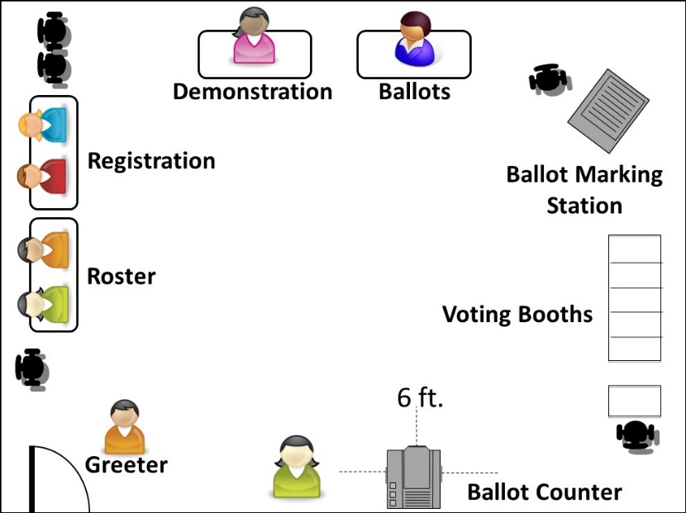

Picture of a suggested set up of a voting room when there are pandemic concerns and/or social distancing requirements:
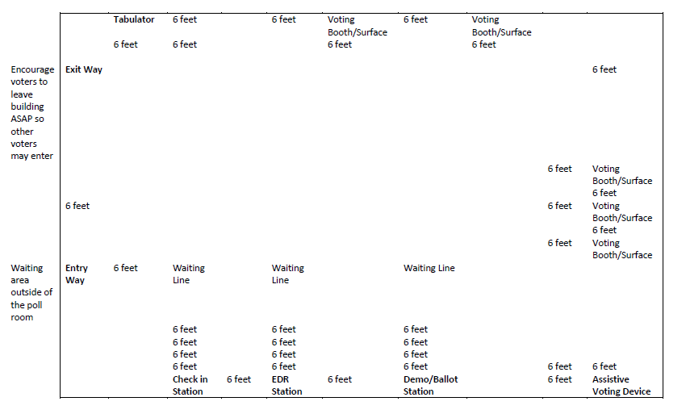
Related statutes & rules: M.S. 206.90, subd. 7; M.S. 204B.18 subd. 1(d)

Equipment Setup
Most precincts will have two pieces of equipment to set up, a ballot marking device and a ballot counter.
Confirm your voting systems work before completing other opening duties; ask the Head Judge to call a local election official immediately if they do not work properly or if there are questions.
Related statutes & rules: M.S. 204B.18

Ballot Marking Device
Except for stand-alone township elections in townships with fewer than 500 registered voters, ballot-marking devices must be present in every polling place. Some ballot markers connect directly to the ballot marker; others are separate devices.
- Set up the ballot marking station on a chair-height table in a place that offers voter privacy.
- The device may require an electrical outlet. If needed, locate a power extension cord.
- The ballot marking table must include a chair. The station should be able to accommodate either a voter who needs a chair or a voter in a wheelchair.
- Set up the ballot marking station in a location that is wheelchair accessible but where others will not confuse it for the ballot counter.
- Set up the station for privacy so that only the voter can see the device’s screen. Face the screen display toward a wall or other private area.
- Test that the device is functioning properly.
Insert a test ballot and verify all offices and candidates are properly displayed on the screen and heard through the headphones.
- Unplug the headphones when not in use.
To prevent others from hearing a voter’s choices, unplug the headphones when not in use.
- Follow any additional setup instructions provided by local election officials.
Related statutes & rules: M.S. 206.84, subd. 6; 206.57, subds. 5 & 5a

Precinct Ballot Counter Setup
Most precincts have a machine, called a precinct ballot counter, which reads the ballots and stores vote totals for reporting after the polls close. A small number of precincts send ballots to a central location for counting at the end of the day or count them by hand.
The ballot counter sits on top of the ballot box. When a voter inserts their ballot into the counter, the machine reads their votes and feeds the ballot into the ballot box for storage. All ballot boxes have one compartment for counted ballots and another auxiliary compartment in which ballots may be manually placed in if the ballot counter becomes inoperable. Some ballot boxes also have a compartment to separate counted ballots that have write-in votes on them.
To set up the ballot counter, follow these steps:
- Verify the seal is intact for the memory stick/card.
The memory card, which stores vote totals, is sealed prior to being delivered. Types of seals vary across jurisdictions—many use plastic lock seals. Inspect for obvious signs of tampering with the memory card, seals, and associated data ports on voting equipment.
- Verify that each ballot box compartment is empty of any ballots.
Check for supplies delivered to the precinct inside the box.
- Lock or seal the ballot counter on top of the ballot box & turn it on.
Some jurisdictions deliver the ballot counter already locked and sealed. In this case, you may need to verify and document the seal number.
- Verify that the offices & candidates from the ballot counter match the ballots.
To do this, print a zero totals tape, which lists the offices and candidates the machine was programmed to count. Check that order of the candidates on both the tape and the ballots match. Contact your local election official immediately if there are any doubts whether the offices and candidates match the zero tape.
- Do not tear the tape off when it is finished printing.
Roll the tape up and keep it intact. The tape must be attached to your official results tape at the end of the day.
There are four ballot counters used in Minnesota (from left to right): DS200, M100, ImageCast Evolution & Verity Scan
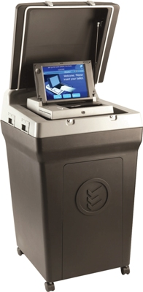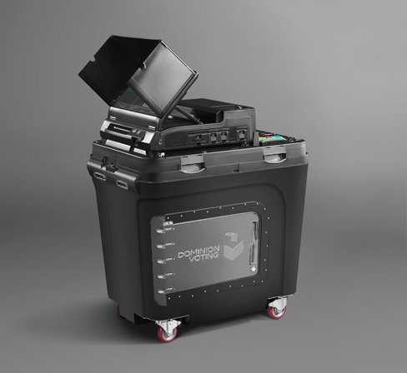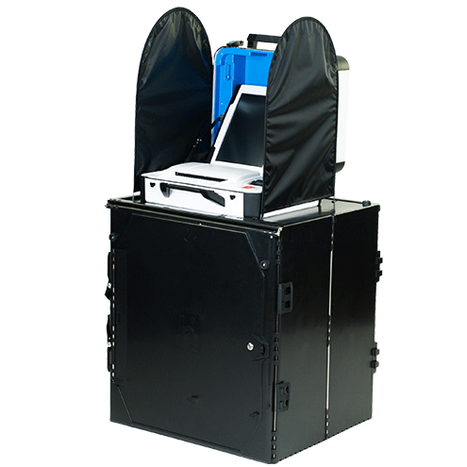

Special Instructions for Central Count Precincts
In central count voting system precincts, one judge locks the ballot box and gives the key to another judge. The ballot box remains locked throughout the day until the ballots are counted. A numbered seal can be used in place of a lock.

Preparing Ballots
- Certify the total number of ballots provided to the precinct.
To do this, count the number of ballot packets. The ballots are wrapped in packets of 25, 50 or 100 ballots. Record the results on the form provided in your supplies.
- Confirm that your precinct’s ballots match the offices & candidates from the ballot counter.
If your polling place contains multiple precincts or has multiple ballot styles, confirm, and prepare a supply for each style needed. Contact your local election official immediately if there are any doubts whether the offices and candidates match.
- Count ballots in each packet.
It is not uncommon for a packet to have less or more ballots than listed on the package (for example, it might have 23 ballots instead of 25). A judge must carefully count each packet as they are opened throughout the day. Fan the ballots to be certain that two are not stuck together. Record any discrepancies as +1, -1 in the Incident Log. Some jurisdictions provide an additional form for tracking ballots during the day.
- Initial each ballot.
After counting the ballots, two judges must write their initials on each ballot that will be given to a voter. Be careful not to make any other marks on the ballot. Any two judges may perform this task—judges from two different major parties are not required.
- Open ballot packs only as needed.
To ensure ballot orderliness and security, do not open more packs than necessary for voting. Start with a modest supply and open more packets only as needed during the day. Store the remaining ballot supply in a secure place until needed. Notify the Head Judge if the ballot supply becomes low.
- Get out a supply of secrecy covers.
Polling places using a precinct ballot counter offer a secrecy cover to voters. This is a folder into which the voter can place their ballot when moving about the polling place. It prevents other voters from seeing their vote choices. Use of the secrecy cover is at the voter’s discretion.
Related statues & rules: M.S. 204C.09, subd. 1

Opening the Polls
When opening time arrives, announce, “The polls are open.” Generally, voting hours are from 7 a.m. to 8 p.m. Your local election official will notify you in advance if voting hours will be different in your precinct.
Related statutes & rules: M.S. 204C.05

Open Polls Regardless of Equipment Failure
You must open the polls at the appointed time even if voting equipment is not working. Have a judge call your local election official and follow these instructions:
- Do not keep voters waiting while you try to get the ballot counter working—immediately utilize the auxiliary compartment slot of the ballot box. This slot lets voters drop their ballot into the locked ballot box without being counted by the machine. The ballots will be processed later in the day.
- Voters may use the ballot marking device to mark their ballot or to verify their ballot has no marking errors.
- Two election judges will process the ballots through the ballot counter during the day or after the polls close.

Greeter Judge
As a Greeter Judge, you will direct the flow of voters and help with other duties as assigned. You observe activity near the entrance of the polling place and ensure that unauthorized individuals are not lingering, and that campaigning is not taking place. Duties include the following.
- Welcome & guide voters.
- For precincts using paper rosters, direct voters to either the Pre-Registered or Registration table.
  - You will have a Greeter’s List that shows all the pre-registered voters in the precinct. When a voter arrives, check the list to see if they are registered or not. Direct them to the roster or registration tables as appropriate.
  - If a voter is not on the list and needs to register, use the precinct finder to confirm they are in the correct polling place. Explain the authorized proofs of residence they will need and direct them to the registration table.
  - If a voter is not at the correct polling place, refer them to the correct location providing address and directions. Remind voter that voting ends at 8 p.m. and they must be in line by that time to vote.
- For precincts using electronic rosters, direct voters to the check-in station.
  - Even if there are electronic rosters in the polling place, you will have a paper Greeter’s List that shows all the pre-registered voters in the precinct. When a voter arrives, check the list to see if they are registered or not.
  - If a voter is not on the list and needs to register, use the precinct finder to confirm they are in the correct polling place. Explain the authorized proofs of residence and ask them to gather those documents before arriving at a check-in station.
  - If a voter is not at the correct polling place, refer them to the correct location providing address and directions. Remind voter that voting ends at 8 p.m. and they must be in line by that time to vote.
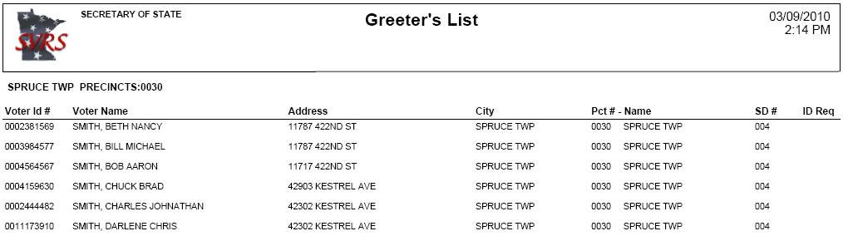
- Provide chairs for voters.
Provide chairs for voters who need to sit while voting or waiting to vote, as well as a flat writing surface for completing forms.
- Greet authorized polling place visitors & direct them to the Head Judge.
Related Statues & Rules: M.S. 204B.18 subd. 1(d)

Roster Judge
As Roster Judge, you sign-in voters who are already registered. If there are enough judges, divide the roster into alphabetical sections (such as A-L, M-Z) to speed up the process. Use signs provided or make signs if needed, so voters can easily see where to go.
If electronic rosters are used, refer to specific instructions provided by local election officials. Confirm sufficent battery power and locate required paper backup rosters and supplemental reports. Remember paper backup rosters are only to be used if given permission by your local official.

Checking in Pre-Registered Voters
- Ask for name & address.
Do not ask a voter to look at the roster themselves to locate their name.
- If the voter had a name charge or moved to a new address, the voter must re-register at the Registration Table.
- A voter may hand you an ID to assist with locating their name, particularly if the spelling is difficult. This is the voter’s choice and is not required.
- Check for a roster notation.
If you see a notation next to their name, please read the section in this guide on “roster notations.”
- Point to the oath & have them sign next to their name.
By signing, the voter affirms the oath of eligibility. In precincts using electronic rosters, the oath is printed on the voter signature slip.
- Give them a voter receipt & direct the voter to the Demonstration/Ballot Judge Table.
They will need a voter receipt to get a ballot from the Ballot Judge. If your precinct has multiple school districts with separate ballots, note the voter’s school district on the voter receipt so that the Ballot Judge gives the correct ballot. Note party preference if it is a presidential nomination primary election.
Related statutes & rules: M.S. 204C.10

Voters Who Have Difficulty Signing the Roster
A voter who cannot sign their name can make a mark, use a stamp facsimile, or request that another person write the voter’s name in their presence. If another person writes the voter’s name, that person should sign their own name as well. If a voter signs with a mark, the election judge certifies the mark by signing the voter’s name for them.
Related statutes & rules: M.S. 201.056

Voter Receipts
Roster and Registration Judges issue voter receipts. Each receipt represents a signature on the roster. Voter receipts are like a ticket for a ballot—the Ballot Judge cannot issue a ballot without first receiving a receipt. Careful management of voter receipts can save time and energy during closing activities. Jurisdictions are allowed flexibility in their design and use receipts. Be sure to follow specific directions provided to you by your clerk.
If a precinct includes multiple school districts, confirm instructions to identify school district of voter on receipt.
During the presidential nomination primary, confirm instructions to identify the party choice of the voter on the receipt.

Roster Troubleshooting Tips
Below are some reasons why a voter may not appear on the roster (even if they believe they should be on it), as well as cases in which a voter whose name is on the roster must re-register before voting.
- Voter is at the wrong precinct.
Check the voter’s address in the precinct finder or precinct map.
- Voter submitted a registration application less than 20 days before the election.
Election law did not allow election officials to add the voter’s name to the Pre-Registered Roster. The voter must register at the Registration Table. If the voter received a Notice of Late Registration in the mail and brought it with them, it can serve as their proof of residence.
- Voter is in the Safe at Home Program
Minnesota statutes, section 5B.06 states that the name and address of a Safe at Home participant must not be listed in the statewide voter registration system. Therefore, their names will not be found on a roster in the polling place on Election Day.
Safe at Home participants vote by an absentee ballot and that process is outlined in statutes and administrative rules. Participants’ absentee voting is coordinated by the Minnesota Safe at Home office.
There is no process for a participant to vote at the polling place.
If a voter offers that they are a participant of the program, have them contact the Safe at Home offices immediately for next steps.
Safe at Home office phone numbers are: 651-201-1399 (metro area), 1-866-723-3035 (greater Minnesota), 711 (Minnesota relay service)
- Voter’s name was automatically removed.
As part of list maintenance voters who have not voted in the last 4 years are removed. The voter must register at the Registration Table.
- Voter is on the roster but had a legal name change.
The voter must register at the Registration Table. Their previous address in the precinct can serve as their proof of residence.
- Voter’s name was left off due to clerical error.
Encourage the voter to register. If the voter refuses or does not have the authorized proofs of residence, ask the Head Judge to contact the county auditor’s office for guidance. The Head Judge may need to administer the Emergency Voting Procedure.
- The voter changed addresses within the precinct.
The voter must register at the Registration Table. This includes any move, including an apartment change in the same building. Their prior registration in the precinct can serve as proof of residence.
- The voter moved out of the precinct.
The voter will have to go to their new precinct to vote.
- The voter’s name, address, or date of birth on the roster contains a clerical error.
The voter is not required to re-register. Ask the Head Judge how to note the correction in the Incident Log or on the Roster Correction Sheet (if provided). Do not mark the correction on the roster itself.

Tips for Locating a Name
- Check spelling variations.
For a name like Hanson, check both Hanson and Hansen. For a name like Bob, check both Bob and Robert.
- See if the first & last names were switched.
Make sure a name such as Vang Lee is not listed as Lee Vang.
- Check multiple combinations for two-word & hyphenated names.
If you cannot find ‘Anderson-Smith’ look also for Anderson Smith or Andersonsmith. Check under Smith in case Anderson was entered as a middle name.
- See if an apostrophe was omitted.
A name like O’Brien might be in a different location within the O’s depending on whether the apostrophe is entered or not.
- Confirm roster pages are in the correct numerical order.
- If it is a common name, check multiple pages for name.
- If paper rosters are split by alphabet, see if a roster page was misplaced in another binder at roster station.
- If using an electronic roster, try reducing the amount of information you used to search for the voter or try searching by address instead.

Keep the Roster Accurate & Orderly
The roster is a legal document that indicates a voter received and cast a ballot. Maintain it carefully.
- Keep the roster free of unnecessary handwriting.
Do not mark an ‘X’ on the roster to indicate where the voter should sign. An ‘X’ may be confused with a voter signature or mark.
- If the voter’s name, address, or date of birth contains a clerical error.
Ask the Head Judge how to note the correction in the Incident Log. Some jurisdictions provide a separate form for recording roster corrections. Do not mark the correction on the roster itself.
- Voter signed their name on the wrong line.
Draw an arrow to the correct line.
- Voter signed the roster but then learns they must re-register.
Ask the Head Judge for assistance.
- Be careful with common names.
Make sure you have the right ‘John Smith’ in front of you, so they do not sign the wrong roster line. If you have any doubt about a person’s identity, you can ask them to state full name, address, and/or date of birth.
Note: Voters who registered prior to 1983 were not required to provide a date of birth, so it may not be on the roster. In this case, you cannot ask for the voter’s date of birth.
Related statutes & rules: M.S. 201.071 subd. 3

Roster Data is Confidential
The roster contains confidential information. Election judges should not examine roster data other than what is necessary to assist the voter before them. The only time a voter can see the roster is at the time when they must sign their name.
Election judges must conceal roster challenge notations of voters from the view of other voters. Confirm with head judge the procedures used in the polling place to conceal roster notations.

Picture of a paper voter roster:
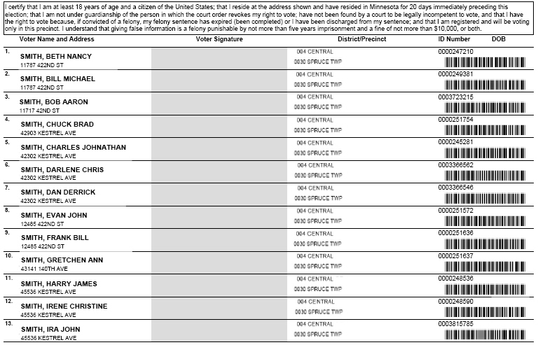
Related statutes & rules: M.S. 204C.10(e)

Roster Notations
Occasionally there will be a word or abbreviation on the line in the polling place roster where voters sign their name—these are called roster notations. The most common roster notations are indicated below. If you have other notations on your roster, contact your local election official for guidance.
- A.B: The voter has already voted by absentee ballot and cannot vote again in-person at the polling place.
- See ID: The voter is a new Minnesota voter who registered by mail, but election officials could not verify their application information. The voter may complete their registration and vote by showing the Roster Judge any proof of residence used for Election Day Registration, except for vouching. If the only proof of residency the voter can provide is vouching, the voter must re-register at the Registration Table.
Notations indicating a ‘challenged’ voter mean that the individual cannot sign the roster without completing additional steps. Your Head Judge will address these issues or instruct you in resolving them. In any discussions with people who have roster notes, it is essential to be courteous and tactful. Do whatever you can to help maintain voters’ privacy.
- Challenged—Felony: The voter may have had a previous felony conviction. A voter with a previous felony conviction can vote after they finish their entire sentence. This includes any probation and parole, commonly known as being ‘off-paper’. At that point, their voting rights are automatically restored. If the voter claims to have completed their entire sentence, use the challenge procedure described in the section below.
- Challenged—Guardianship: The voter may be under court-ordered guardianship with their voting rights revoked. Voters under guardianship can vote unless their court order explicitly revoked that right. If the person says that they are eligible to vote, use the challenge procedure described in the section below.
- Challenged—Voted Out of Precinct: The voter was recorded as having voted in the wrong precinct at the last election. The voter will need to provide the Roster Judge a proof of residence used for Election Day registration prior to voting.
- Challenged—Name & Address: The voter’s true name and residency at the address on the roster are in question. If the voter says that they are eligible to vote in that precinct, use the challenge procedure described in the section below.
- Challenged—Address: The voter’s residency at the address on the roster is in question. If the voter says that they are eligible to vote in that precinct, use the challenge procedure described in the section below.
- Challenged—AB Address: The voter submitted an absentee ballot application that lists a residential address different from the address currently listed on their voter record. If the voter says that they are eligible to vote in that precinct, use the challenge procedure described in the section below.
- Challenged—Postal Return: The voter was sent a postal verification card that was returned to the auditor because it was not deliverable to the person at the address on record. If the voter says that they are eligible to vote in that precinct, use the challenge procedure described in the section below.
- Challenged—Unverified: The identification number(s) that the voter has provided on their voter registration application was not verified. If the voter says that the number they provided is correct, use the challenge procedure described below to confirm the voter’s name and date of birth.
- Challenged—Other: The voter’s eligibility is challenged, but the reason is not available. If the voter says that they are eligible to vote, use the challenge procedure described in the section below.
Related statutes & rules: M.S. 201.061 subd 1a; 609.165, subd. 1

Roster Challenge Procedure
If a voter has a notation indicating a challenge, the Roster Judge or Head Judge must question the voter to resolve the challenge. Some questions may be quite personal in nature. To avoid embarrassing the voter or upsetting those nearby, consider questioning the voter in private. Use the following procedure:
- Have the voter swear or affirm the following:
‘Do you solemnly swear (or affirm) that you will fully and truly answer all questions put to you concerning your eligibility to vote at this election?’
- Ask appropriate questions to determine if they are eligible.
The questions you ask will depend on the nature of the challenge. Examples include:
- Residency: If residency in the precinct is in question, refer to the Residency section in this guide.
- Felony: ‘Are you on probation or parole for a felony conviction?’
- Guardianship ‘Are you under court-ordered guardianship in which the court revoked your right to vote?’ ‘Were you found by a court to be legally incompetent?’
- Citizenship: ‘Are you a citizen of the United States of America?’
- Name and address: ‘What is your full name; what is your residential address?’
- Address: ‘What is your residential address? Note: See homeless voter who does not have a residential address information in this guide.
- Absentee Ballot (AB) address: ‘What is your residential address?’; ‘Did you submit an application for an absentee ballot using another residential address?’; ‘Have you returned that voted absentee ballot?’
- Postal return ‘What is your residential address?’ Note: See homeless voter who does not have a residential address information in this guide.
- If voter’s answer(s) indicate they are eligible to vote in the precinct:
Draw a line through the roster notation in the roster. The voter may proceed to sign the roster and vote.
- Make notations in the Incident Log as appropriate.
Some jurisdictions may provide an additional form for recording roster challenges.
Related statutes & rules: M.S. 204C.12

Refusing or Failing a Challenge
If a voter refuses to answer questions, is not eligible, or refuses to sign the roster, inform the voter that they cannot vote now or later in the day. Print ‘Refused Oath’ or ‘Not Eligible’ on the signature line and make a note in the Incident Log.

Registration Judge
As Registration Judge, you conduct Election Day registration for those who need to register. Approximately 10% to 20% of all Minnesota voters typically register on Election Day. A registration judge is prohibited from handling ballots of voters they have registered until the polls are closed.

Voter Eligibility
To register, a person must be a U.S. citizen, at least 18 years old on Election Day and a resident of Minnesota for 20 days. They must be finished with all parts of any felony sentence. A person can vote while under guardianship unless a judge specifically has revoked their right to vote. A person cannot vote if a court has ruled that they are legally incompetent.

Registration Steps
- Verify the voter is at the right polling place.
An individual can only vote in the precinct where they reside. It is common for a voter to go to the wrong polling place. Use the precinct finder or a precinct map to verify addresses in your precinct. If residency questions arise, refer to the Residency section of this guide.
- Confirm the voter has not already voted absentee.
Before letting an individual register to vote on Election Day, review any lists of absentee Election Day registrants provided by your local election administrator. If the individual’s name appears on this list, they cannot register or vote in the polling place on Election Day. Their absentee ballot has already been counted.
- Ask the voter to complete a registration application.
For step-by-step instructions on completing the voter registration application, see information in this guide. Make sure the voter reviews the oath before signing and dating. Review the voter registration application and ask the voter to complete any blank items in the shaded areas or correct unreadable information.
Note: If you are running out of voter registration applications, you may make photocopies of an official voter registration application for voters to use until more applications are available.
- Confirm the voter’s proof of residence.
Everyone who registers on Election Day must have proof of residence in the precinct. Only proofs authorized by law may be used. There are seven ways to prove where you live; the voter need only provide one. Refer to the next section for these proofs. Keep a running total of the number of persons who are unable to provide an authorized proof of residence.
- Complete the election judge’s section on bottom of the voter registration application.
Indicate the type of proof the voter used in the bottom of the application marked ‘Election Judge Official Use Only.’ Include an ID number if the document has one. Complete all relevant areas, including ward, precinct, and school district boxes on the left, along with your initials.
- Have the voter complete & sign the Election Day Registration Roster.
Have newly registered voters print their name, address, date of birth and sign their name on the Election Day Registration Roster.
- Hand them a voter receipt & direct them to the Demonstration/Ballot Judge.
The judge who registers a voter cannot also distribute ballots to that voter.
Related statutes & rules: M.S.201.061; 204C.10; M.R. 8200.5100

Proofs of Residence
Everyone who registers on Election Day must provide one of the proofs of residence listed below. Only proofs authorized by law may be used. A voter is allowed to leave and come back in order to get what they need to register.
- ID with voter’s current name & address
Voters may use the following IDs with their current name and address in the precinct:
  - Valid Minnesota driver’s license, Minnesota learner’s permit or Minnesota ID card.
  - The yellow receipt for a Minnesota driver’s license, learner’s permit, or ID card.
  - Tribal ID card with name, current address, signature, and picture issued by the tribal government of a tribe recognized by the Bureau of Indian Affairs. Tribal band members are not required to live on an Indian reservation to use a tribal identification card to prove residence.
When presented with a Minnesota license, look for a “status check” notation in the lower right-hand corner. If you see this, it indicates the voter was not a citizen at the time they applied for the license. They may or may not have become a citizen since obtaining the license. If they state they are eligible to vote, you or the Head Judge must follow the Roster Challenge Procedures found in this guide.
- Photo ID plus a document with name & current address
Voters must show both one photo ID and one document. The ID must contain the voter’s name and photo and can be expired. The document must have the voter’s name and current address in the precinct and can be shown electronically or on paper.
Approved Photo IDs (choose one)
  - Driver's license, state ID or learner’s permit issued by any state
  - United States passport
  - United States Military or Veteran ID
  - Tribal ID with the name, signature, and photo of the voter
  - Minnesota university, college, or technical college ID
  - Minnesota high school ID
Approved Documents (choose one)
  - Residential lease or rental agreement (must be valid through Election Day)
  - Current student fee statement
  - Bill, account or start of service statement due or dated within 30 days of election for:
    - Phone (landline, cell, VOIP, etc.)
    - TV (cable, satellite, etc.)
    - Internet
    - Solid waste or sewer
    - Electric, gas or water
    - Banking or credit card
    - Rent or mortgage payments
- Registered voter who can confirm the registrant’s name & address
A voter registered in the same precinct can sign an oath attesting to a new registrant’s residence. This is called ‘vouching.’ A registered voter can vouch for up to eight voters whom they personally know live in the precinct. The person who does the vouching can also have registered on Election Day by using any proof of residence option, except for vouching—once a voter registers by being vouched for, that person cannot in turn vouch for others. Note: Residential facility vouchers do not have an eight-voter limit—see Option 7 below.
Here are the steps for processing a voucher:
  - Have voucher complete the Voucher Form on the back side of the registration application or a separate form.
  - Review what the voucher has written, ensure that all items are complete and then sign the form.
  - Each pre-registered voter has a unique identification number assigned them. Find the voucher’s identification number on either the Pre-Registered Roster or the Greeter’s List and record it on the Precinct List of Persons Vouching form. If the voucher registered on Election Day, an identification number may not be available.
  - For precincts using electronic rosters, the voucher process is handled on the electronic roster.
  - Record the number of persons the voter vouched for on the same form.
- College student ID—if a student housing list was provided
Your precinct may be provided with a list of students housed at a Minnesota postsecondary educational institution. If so, a student named on that list can register by showing a current, valid student ID card from that same institution. The ID must have their photo.
- Valid registration in the same precinct
If a voter is currently registered in the precinct but changed names or moved within the same precinct, their registration serves as proof of residence — no additional documentation is needed.
- Notice of Late Registration
The voter can show a Notice of Late Registration from the county auditor or city clerk. A voter may be sent a Notice of Late Registration if they register less than 21 days before the election.
- Staff person of a residential facility
If the voter lives in a residential facility, a staff person from the facility can vouch for their residency with a signed oath. Unlike registered voter vouchers (see Option 3 above), residential facility staff may vouch for any number of voters living in the facility.
- Residential facilities include nursing homes, veterans’ homes, developmental disability care facilities, shelters, or temporary living facilities for homeless persons, battered women’s shelters and other types of licensed facilities.
- If a list of facility staff is provided prior to the election, your local election official will include it in your supplies. If no list is provided, a staff person can demonstrate their employment at that facility another way, such as providing an employee badge or a letter from the employer.
- Have the voucher complete the Voucher Form on the back side of the registration application or on a separate form. Do not record this type of voucher on the Precinct List of Persons Vouching form.
Related statutes & rules: M.R.8200.5100

Completing the “Election Judge Official Use Only” Section
You must document the details of the voter’s proof of residence at the bottom of the application. You may encounter one of two slightly different forms, depending on their print date. Both forms are acceptable.
If using an older form, make edits as needed to account for new proofs of residence. For example, if a voter presents an out-of-state driver’s license, you may cross out ‘MN’ on the form when indicating the type of photo ID they provided (see example below) and write the state’s abbreviation on the ID Number line. Or, if a voter presents a veteran ID, handwrite ‘veteran ID’ next to the ‘U.S. Military ID’ box.
Pre-2014 Election Judge Section
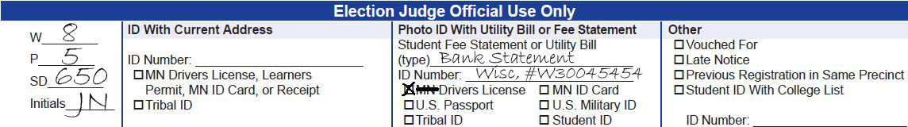
Current Election Judge Section
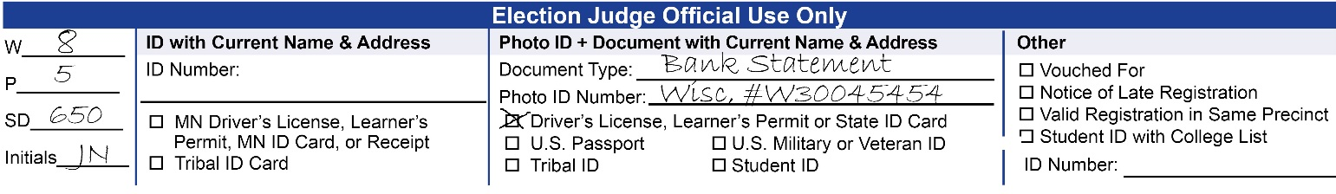

Tips for Completing ‘Photo ID + Document with Current Name & Address’ Column
If the voter presents an out-of-state ID, note which state it is on the ID number line (see example). Do this regardless of which form you are using. If the ID is from Minnesota, you do not need to note the state on the ID number line.

Tips for Completing the ‘Other’ Column
- Vouched For
Write ‘See Back’ or ‘See Voucher Certificate’ in the ‘ID Number’ space, as additional voucher details are recorded on the backside of the form or on a separate form.
- College student ID—if a student housing list was provided
Write the number listed on their school ID.
- Valid registration in the same precinct
Find the voter’s record in the pre-registration roster and write the voter’s ID number.
- Notice of Late Registration
Write the voter’s ID number listed in the upper right-hand corner of the Notice of Late Registration, if available. First-time registrants may not have an ID number listed; if so, write ‘Not Available.’

Using the Precinct Finder
The precinct finder is a reference sheet for all street addresses in your precinct. It does not list each address individually, but instead groups them into address ranges. In some cases, it will also separate them by odd and even numbered addresses. Follow these steps to use the precinct finder.
- Find the voter’s street, listed in alphanumeric order.
- Find the address range that fits the voter’s house number.
- Because some streets serve as precinct boundaries, voters on one side of the street might be located in a different precinct from their neighbors on the other side. Watch for address ranges labeled for only the odd or even house numbers:
- O designates that the address range is only for odd house numbers;
- E designates that the address range is only for even house numbers;
- B designates that the address range is for both sides of the street (either odd or even house numbers).
If the voter’s address cannot be located, use a map to determine if they are at the wrong polling place. If they are, call an election official or instruct them to visit the polling place finder found on the Secretary of State website (mnvotes.gov). At the discretion of your local election official, you may use a laptop, smartphone or another mobile device to assist the voter in locating their polling place site and directions.
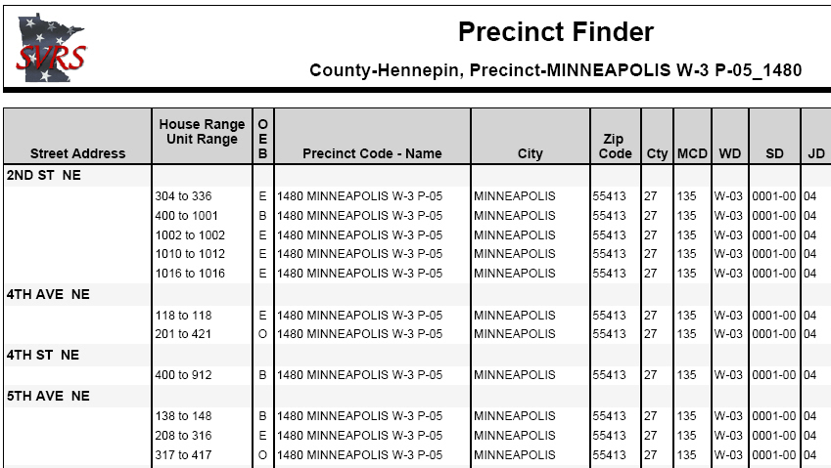

Common Residence Questions
If needed, principles for determining residence are provided in M.S. 200.031 (https://www.revisor.mn.gov/statutes/cite/200.031) which can be found in this guide.

Multiple Houses
For voting purposes, a person can have only one residence. If the voter owns multiple houses, the voter must decide which is their principal residence. They should consider factors such as where they sleep most nights and where their family lives.

Home Damaged Due to Disaster
If a voter intends to return to the home after it is rebuilt or repaired, they do not lose residence at that location. If they do not intend to return to the home, they no longer reside there.

Student Residency
Students may choose to vote either at home or in the precinct where they live while attending school, depending on which they consider their residence. The special provisions for Election Day registration for students are in the Proof of Residence section above.

Voter Does Not Have a Home
A voter who is homeless may register and vote. Their residence is where they sleep, be it a shelter, a friend's house or outside. If their residence does not have an address, provide a description of the location on line 4 of the registration application (i.e., ‘bridge at the corner of Washington Ave E & Lincoln Place’). If they do not typically sleep in the same place, they should put the location where they slept the previous night. They can list a mailing address on line 5 if they have one, but cannot list a mailing address as a residence. For instance, a PO Box or a ‘General Delivery’ cannot be used as a residence.

Roster Data is Confidential
Rosters contain confidential information. Election judges should not examine roster data other than what is necessary to assist the voter before them. The only time a voter can see the roster is at the time when they must mark it to obtain a voter receipt.
Election judges must conceal roster challenges of voters from the view of other voters.

Address Confidentiality
While the rosters contain confidential information, the names and addresses of people who register become public information. If the voter fears someone might harm them or their family, they might not want their name on the list. At the time of registration, these voters have the option of presenting you a signed statement that withholding their name from the public information list is required for safety reasons. The Secretary of State and county auditor will then withhold the name from the public information list. If a voter provides such a statement, be sure to attach it to their registration form.

Demonstration Judge
As Demonstration Judge, you instruct voters how to mark the ballot and how to deliver it to the ballot box. In most cases, the Demonstration Judge is also assigned to be the Ballot Judge.
Some jurisdictions provide demonstration ballots in the polling place materials for your use, while others print demonstration ovals on the receipt voters receive from the Roster or Registration Judge. Whatever the case, remember to remain impartial as you work with voters. Never demonstrate using an official ballot and do not point to a specific candidate or party when demonstrating how to mark a ballot. Specific ballot marking instructions for different types of ballots and elections are below.
Be ready to give written instructions to voters who are deaf, deafblind, or hard of hearing. You may want to have a copy of this guide next to you at the demonstration table to serve this purpose.
Related statutes & rules: M.S. 204C.16

Voter Instructions
Provide these instructions to voters using an optical scan ballot (a ballot that can be read by a ballot counter).
- Vote only with the pen provided; the scanner may not detect marks made with certain pens.
- Make your selection by filling in the oval next to the candidate or question on the ballot.
- When finished, place your ballot into the secrecy cover.
- Insert your ballot into the ballot counter or ask for assistance.
- You can ask for a replacement ballot if you make a mistake and need a new one.
Related statutes & rules: M.S. 204C.13

Additional Instructions for Primaries

Partisan Primaries
- No write-in votes are allowed.
- The ballot will have a column for each major political party. You can only vote for candidates from a single party. You cannot vote for candidates from more than one party. Voting for candidates from more than one party voids all votes on the partisan portion of the ballot.
- Minnesota does not have political party registration. You are not required to publicly declare affiliation with a party. All voters receive the same ballot.

Combined Partisan & Nonpartisan Primaries
- No write-in votes are allowed.
- For partisan offices, choose candidates from a single party.
- For nonpartisan offices, choose any candidate.

Presidential Nomination Primaries
- The ballot will be specific to the party chosen at the roster or registration station.
- One of the candidate choices might be “undeclared.”
- Write-in votes might be allowed. The party chair chooses if write-ins will be included on their ballot.

Additional General Election Instructions
- You can vote for candidates from different major political parties (in contrast to partisan primaries).
- You can vote for up to the number of people allowed for each office.
- Blank spaces are provided on the ballot for write-ins for each office. To cast a write-in vote, fill in the write-in oval and write in the name of a candidate who is not on the ballot.
- A sticker may not be placed on the ballot for any reason.

Constitutional Amendment Instructions
Constitutional amendments have voter instructions printed directly on the ballot. Election judges should not be proactively telling voters that not voting on a constitutional amendment has the same effect as voting no. This may influence how people vote, which election judges are not permitted to do. If a voter asks, direct the voter to the printed instructions on the ballot.

Ballot Question Instructions
Ballot questions have voter instructions printed directly on the ballot. If a voter asks questions as to what a yes or no vote means, direct them to the printed instructions for the ballot question.

Special Elections
Your local election official will give you instructions about any special election that is scheduled.

Ballot Judge
As Ballot Judge, you count and track packs of ballots, collect registered voter receipts and issue ballots. Be sure to always keep the ballots under control. Track your ballot counts carefully—at the end of the day, you will be required to reconcile the number of ballots originally sent to the precinct with the number of returned ballots. If you err in tracking these numbers, you may be in for a long night as you try to figure out exactly what happened. If you are stuck on a step, call your local election official.

Counting & Initialing Ballots
- Certify the total number of ballots provided to the precinct.
To do this, count the number of ballot packets. The ballots are wrapped in packets of 25, 50 or 100 ballots. Record the results on the form provided in your supplies.
- Confirm that your precinct’s ballots match the offices & candidates from the ballot counter. If your polling place contains multiple precincts or has multiple ballot styles, confirm, and prepare a supply for each style needed. Contact your local election official immediately if there are any doubts whether the offices and candidates match.
- Count ballots in each packet.
It is not uncommon for a packet to have less or more ballots than listed on the package (for example, it might have 23 ballots instead of 25). A judge must carefully count each packet as they are opened throughout the day. Fan the ballots to be certain that two are not stuck together. Record any discrepancies as +1, -1 in the Incident Log. Some jurisdictions provide an additional form for tracking ballots during the day.
- Initial each ballot.
After counting the ballots, two judges must write their initials on each ballot that will be given to a voter. Be careful not to make any other marks on the ballot. Any two judges may perform this task—judges from two different major parties are not required.
- Open ballot packs only as needed.
To ensure ballot orderliness and security, do not open more packs than necessary for voting. Start with a modest supply and open more packets only as needed during the day. Store the remaining ballot supply in a secure place until needed. Notify the Head Judge if the ballot supply becomes low. Do not issue the last ballot.
- Get out a supply of secrecy covers.
Polling places using a precinct ballot counter offer a secrecy cover to voters. This is a folder into which the voter can place their ballot when moving about the polling place. It prevents other voters from seeing their vote choices. Use of the secrecy cover is at the voter’s discretion. If there are not enough secrecy covers, offer the voter the choice of voting without a secrecy cover.
Related statutes & rules: M.S. 204C.09, subd. 1

Ballot Shortages—Unofficial Ballots
- When the supply of ballots at the polling place runs low, contact your local election official who should be able to provide you with additional ballots.
- Under no circumstance should the last ballot at the polling place be given to a voter – keep it to use for making unofficial ballots. Make unofficial ballots by photocopying or otherwise reproducing ballots. Do not wait until all the ballots are gone before making unofficial ballots. Check with your local election official before doing so and note on the Summary Statement how many were made. Do not keep voters waiting.
Related statutes & rules: M.S.204B.30

Issuing Ballots
- Each ballot must bear the initials of two election judges.
- Only issue a ballot after collecting a valid voter receipt.
If your polling location has multiple precincts or ballot styles, be sure to issue the voter the correct ballot.
- If using a ballot counter, offer a secrecy cover.
- Instruct the voter how to mark the ballot.
If you are also designated as the Demonstration Judge, instruct the voter how to mark the ballot. Direct them to an unoccupied voting booth or ballot marking station. The voter may use another writing surface at their discretion. To ensure secrecy, only one person is allowed in a booth at a time unless they request help or have brought an assistant with them
- Voters can use a reasonable amount of time to vote.
If someone is taking an unusually long time, remind them that others are waiting and ask if they need assistance. If they do need help from election judges, remember that two election judges from different major political parties must provide assistance.
- No one can take any official ballots from the polling place.
Only an election judge helping a curbside voter can take an official ballot from the polling place.
Related statutes & rules: M.S. 204C.13

Spoiled & Found Ballots
A spoiled ballot is one that a voter returns to a judge because they made an error while marking it. Give them a replacement ballot. Do not examine the spoiled ballot unless the voter requests help or you need to determine what style of replacement ballot to give the voter.
If a voter abandons a ballot in the voting booth, print ‘Found in booth’ on the ballot. The votes on the ballot will not be counted. Keep any spoiled or found ballots in the Spoiled Ballot Envelope. Record any such events in the Incident Log. Some jurisdictions provide additional forms for this purpose.
Related statutes & rules: M.S. 204C.13; M.R. 8230.1050

Ballot Marking Device
Except for stand-alone township elections in townships with fewer than 500 registered voters, ballot-marking devices must be present in every polling place so that all individuals have the same opportunity for access and participation. It provides privacy and independence to voters who cannot, or choose not, to vote using a pen. It can display the ballot in large print or with a high-contrast background; it can read the ballot to the voter through headphones; and it allows the voter to select candidates with a keypad, touchscreen (if applicable), or sip-and-puff device.
Any voter can choose to use a ballot marking device to complete their ballot. In some polling places it is used frequently and in others only rarely—what matters is that it is ready to use when a voter requests it. If you are working in your home precinct, try using it to mark your ballot to familiarize yourself with the system.
Remember to explain that the device does not count ballots. This is important because if a voter mistakenly abandons a ballot in the device, it cannot be counted later. It should be marked ‘Found in Voting Station’ and placed in the Spoiled Ballot Envelope. Record this in the Incident Log immediately so that your end-of-day statistics remain accurate. Some jurisdictions provide additional forms for this purpose.
If you are helping a voter get started on the machine, be sure to leave them in privacy before they start making ballot choices. If the voter specifically requests help using the machine to make choices, two judges from different major political parties must assist the voter in making ballot selections.
Related statutes & rules: M.S. 206.57, subd. 5

Features
When the voter inserts a ballot into the device, an electronic version of it appears on the screen. It allows a voter to view and mark the ballot in various ways:
- It allows selections by touching the screen (if applicable) or pressing keys on the keypad.
- It can read the ballot to a voter by headphones who can then mark it with a keypad.
- The voter can turn the screen off for privacy.
- The audio description of the ballot can be used in place of or in conjunction with the visual version on the screen.
- The device checks for ballot-marking errors, such as cross-party voting during a primary election.
- The device prints their choices on the ballot.

Types of Ballot Marking Devices
There are four ballot marking devices in use in Minnesota. The AutoMARK, the OmniBallot and the Verity TouchWriter are stand-alone machines. The ImageCast Evolution is a combined ballot tabulator and ballot marking device. Details of machine operation will vary. Before voting begins, ask your head judge to explain how the device works and what specific instructions you should give voters before using it.

Pictures of the four ballot marking devices used in Minnesota:
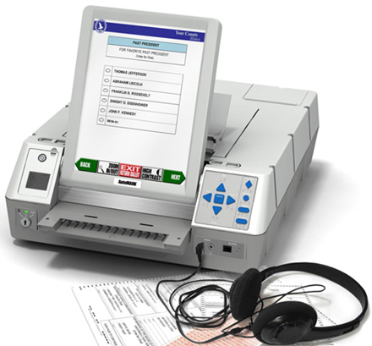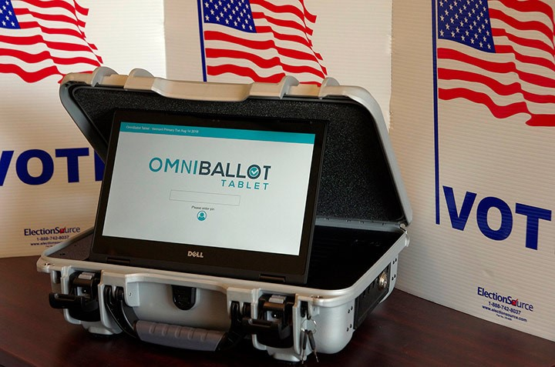
AutoMark OmniBallot
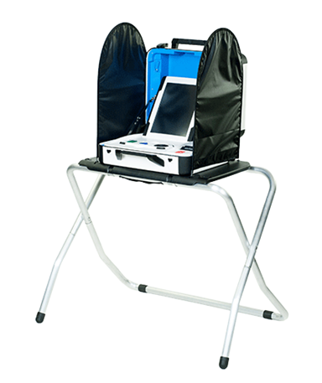
Verity TouchWriter
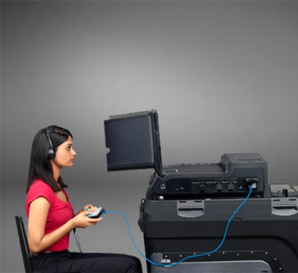
ImageCast Evolution

Ballot Counter Judge
As Ballot Counter Judge, you monitor and troubleshoot operation of the ballot counter and distribute ‘I Voted’ stickers.

Guidelines for Conduct
- Unless they request help, voters insert their own ballot into the machine.
- No one, except for a voter casting their ballot or an election judge, is allowed within six feet of the ballot box. It is good practice to put tape on the floor to mark the six-foot boundary.
- After the voter finishes, offer an ‘I Voted’ sticker. Offer the sticker rather than placing it on the voter.
Related statutes & rules: M.R. 8230.4365 subp. 3; M.S. 211B.11

Assisting with Ballot Errors
The ballot counter checks for ballot errors. If it locates an error, the machine will return the ballot. The tape or display will indicate the error. Here are common errors:
- Skewed ballot
Ballot counters should accept a ballot in any orientation, but rotating and re-inserting it in a different orientation can help. Have the voter turn the ballot around and reinsert it with both hands, keeping it straight.
- Overvoting
Overvoting is selecting more candidates for a single office than is allowed. For example, voters can only choose one candidate for U.S. president—voting for more than one presidential candidate is overvoting. In addition, the device may mistakenly identify stray pen or pencil marks as an overvote.
- Cross-party voting
In a partisan state primary, voters can only vote for candidates from one party. If they vote for candidates from more than one party, their ballot will be returned.
- Blank ballot
The machine will return the ballot if it is completely blank. A voter can cast a blank ballot, if they choose.
Related statutes & rules: M.R. 8230.4365

Procedure for Resolving a Ballot Marking Error
- Check the ballot counter display or tape for the error message.
Do not inspect the voter’s ballot.
- Explain the error to the voter & offer the voter a replacement ballot.
If the voter does not understand your verbal explanation and asks for additional clarification, two judges from different major political parties may discretely review the ballot and advise the voter.
- A voter may insist that the ballot be counted as is.
Explain to the voter that some or all their votes may not be counted. If the voter accepts this, the election judge may use the override or accept button on the ballot counter to cause it to accept the ballot. Voters cannot vote again after their ballot is counted by the ballot counter.
Related statutes & rules: M.R. 8230.4365

Full Ballot Box Procedure
- Two judges from different major political parties may open the ballot box to straighten or empty ballots and make room for more. If removing ballots, keep those from the write-in compartment separate from the others and seal each in separate containers.
- In the Incident Log, record the time, the initials of the judges present and the numbers from any seals used to secure the removed ballots in the transfer case(s). Local officials will provide additional instructions as needed.
Related statutes & rules: M.R. 8230.4365, subp. 5

Troubleshooting a Jammed Ballot
- If a ballot gets jammed in the ballot counter, ask the voter to remain in the polling place.
- Read the error message on the ballot counter to see if the ballot got stuck before or after the machine counted it.
- If ballot was not counted, an error message will indicate a problem ballot or instruct you to reinsert the ballot.
- If the ballot was counted, an error message will instruct that the ballot be manually placed inside the ballot box.
- Remove the jammed ballot. If the ballot is visible, ask the voter to remove it. If not, slide the ballot counter forward and remove the ballot, or open the ballot box and remove it if necessary; then have the voter place the ballot in the secrecy cover.
- If the ballot was counted, deposit it manually into the correct ballot box compartment (the write-in compartment or the regular compartment).
- If the ballot was not counted, ask the voter to reinsert the ballot in a different orientation. If the ballot jams again, read the new error message, and have the voter place the ballot in the secrecy cover. Then accompany the voter to the Ballot Judge, ask for a replacement ballot and place the spoiled ballot in the appropriate envelope.

If Ballot Counter Stops Working
If the ballot counter stops working have a judge call your local election official and follow these instructions:
- Do not keep voters waiting while you try to get the ballot counter working—immediately open the auxiliary compartment slot of the ballot box. This slot lets voters drop their ballot into the locked ballot box without being counted by the machine.
- If needed, explain to voters that once the ballot counter is operating election judges will process them through the ballot counter.
- Voters may use the ballot marking device to verify their ballot has no voter errors before placing it in the auxiliary compartment.
- After the machine is operating again, two judges should remove the ballots from the auxiliary compartment and feed them into the ballot counter.

Rules for Polling Place Conduct

Persons Allowed in or Near the Polling Place
During voting hours, law allows only election judges, people directly engaged in voting and authorized persons to be present. Ask unauthorized people to leave immediately. Authorized persons are:
- Persons helping a voter.
- Children accompanying voters.
- Vouchers.
- Observers with written authorization from the office of the secretary of state, county auditor or clerk.
- Peace officers if judges request their presence to keep order.
- Challengers appointed in writing by a political party or nonpartisan candidate.
- Teachers & elementary & high school students, if participating in a mock election that has been authorized by the secretary of state.
- Persons making a written complaint.
- Media may enter the polling place to observe the voting process so long as they:
- Show photo identification to the Head Judge upon arrival along with either a recognized media credential or written statement from a local election official attesting to their credentials.
- Stay at least six feet from voters.
- Do not converse with voters or interfere with the voting process.
- Do not make a list of those voting or not voting.
- People conducting exit polls can be on the premises, but not in the room where voting occurs. Depending on the building layout, this may mean the pollster must remain outdoors. An individual conducting an exit poll may only approach voters after they have voted and may only speak with a voter to the extent necessary to ask the voter to take an anonymous written questionnaire.
- No one in the polling place should be discussing candidates or issues. This includes voters waiting in line and election judges.
Related statutes & rules: M.S. 204C.06; 204C.13, subd. 2; M.S. 211B.11;

Prohibition on Campaigning
- Campaigning is not allowed in the polling place or within 100 feet of the building. If the polling place is on public property, campaigning is not allowed anywhere on the property, even beyond 100 feet. Note: Per Schimming v. Riverblood, OAH 7-6347-20326-CV (June 5, 2009), the prohibition of signs and campaign materials within 100 feet does not apply to adjacent private property.
- The prohibition includes displaying political or campaign materials in the polling place, including literature or buttons. Ask the individual to either cover up or remove the political material while in the polling place. If they refuse, explain that eligible voters will be allowed to vote, but any refusal will be recorded and referred to appropriate authorities. Record in the Incident Log the names of those who refuse to cover or remove political material.
- Voters may take sample ballots or campaign flyers into the voting booth, but they should not display these materials outside the booth.

Additional Prohibited Conduct
People may not gather or linger in the polling place or within 100 feet of the building. Intoxicated persons and/or liquor are not allowed. Ask individuals to leave if they will not or cannot cease the following:
- Disorderly conduct
- Smoking
- Lingering
Related statutes & rules: M.S. 204C.06

Voter Complaints

HAVA Complaints
The HAVA Complaint Form must be available to voters upon request.
This form may be used when any person believes a violation of the Help America Vote Act (HAVA) Title III (such as voting machine standards, posting of voting information, voter registration) has occurred, is occurring or is about to occur.
It is not for the following complaints:
- Minnesota Fair Campaign Practice & Finance Acts complaints (Minnesota Statutes 211A & 211B). Those complaints are referred to the Minnesota’s Office of Administrative Hearings and are not applicable to this complaint form.
- Other Minnesota election law complaints. Those complaints are referred to the county attorney. Use the Minnesota State Election Law Complaint Form instead.
Instruct the voter of the need to complete the form, including their signature and the requirement that an election judge or notary sign and witness it. Voters may complete it at the polling place or take it with them.
On Election Day, you are authorized to sign as a notary on the HAVA Complaint Form. Your signature does not indicate agreement with the voter’s statement but indicates that you witnessed the voter complete the form.
Make a note in the Incident Log with details of the event. Instruct the voter to deliver the form to the address provided on the form.

State Election Law Complaints
State Election Law Complaint form may be found with other Election Day administration forms.
This form may be used when any person believes a violation of Minnesota election law has occurred, is occurring or is about to occur. This includes complaints related to Minnesota Statutes Chapters 200, 201, 203B, 204C & 206.
It is not to be used for Minnesota Fair Campaign Practice & Finance Acts (Minnesota Statutes 211A & 211B) complaints. Those complaints are referred to the Minnesota’s Office of Administrative Hearings.
After completing this form and having it notarized, it is returned to the county attorney for investigation.
Make a note in the Incident Log with details of the event.
Related statutes & rules: M.S. 200.04

Providing Assistance to Voters
Voters have a right to receive assistance from election judges or a person of their choice, except an agent of their employer or union. This could include assistance moving through the polling place, reading materials, completing forms, or marking ballots. An assistant is not required to be an eligible voter and can be younger than 18 years of age.

Assistance by Election Judges
One election judge may provide assistance to voters, upon request, for most polling place activities (mobility, interpreting ballot instructions at the demonstration station, etc.). One election judge may assist a voter with marking their ballot (there are no longer limits on how many voters a person may assist to mark a ballot).
Two election judges of different major parties may assist a voter with marking their ballot for an unlimited number of voters in one election.
Be sensitive to the specific needs of the voter. Avoid any action that may influence how they vote. Do not give advice or reveal how they voted. Direct questions to the voter, not to others with them. Help only as much as requested.

Assistance from Others
The voter is not required to use election judges for assistance.
An assistant of the voter’s choice, except an agent of their employer or union, may help the voter in all areas of the polling place, including in the voting booth.
As of 2020, there are no longer limits on the “number of voters” a person may assist with marking ballots and candidates may serve as ballot marking assistants.
If an assistant has marked a ballot on behalf of a voter, the voter may show it privately to an election judge or use the ballot marking device to confirm that it is correctly marked before placing the ballot in the ballot box.
Related statutes & rules: M.S. 204C.15, subd. 1

Curbside Voting
There may be instances where a voter is unable to enter the polling place. In this case, the voter can request that you bring a ballot out to their vehicle. Follow these procedures. (The procedures are the same if a paper roster or electronic roster is being used.)
Note: You cannot ask questions of a voter to determine if it is “okay” for them to use curbside voting or not.
- Two judges from different major political parties go out to assist the voter.
Ask and write down their name and return inside to check the roster and determine if the voter is registered.
- Bring a Certificate of Registered Voter form to each curbside voter.
This form takes the place of signing the roster. If not registered, bring a registration application.
- Have the voter complete the form(s).
Ask for proof of residence if they needed to register.
- Process forms.
Give the Certificate to the Roster Judge (if they were pre-registered) or the Registration Judge (if they needed to register) in exchange for a receipt. Have the Roster or Registration Judge print ‘curbside’ on the appropriate roster signature line. Attach the certificate to the page where the voter’s name appears on the roster.
  - If electronic rosters are being used, follow instructions provided by local election official.
- Hand the receipt to the Ballot Judge for a ballot & bring it out to the voter.
- Have the voter fill out the ballot. Aid as needed.
- Place the ballot into the ballot box.
Keep in mind that if only one election judge remains in the polling place while other election judges administer curbside voting, that election judge may not approve an Election Day registration application and then provide a ballot to the same voter.
Related statutes & rules: M.S. 204C.15, subd. 1

Serving Voters Who Have a Disability
Unfortunately, voters who have a disability continue to face barriers at polling places. These include architectural and physical barriers, as well as barriers from election personnel who have not been properly trained. Over half of respondents in a recent national survey reported encountering barriers, including attitudinal, inside the polling place. 20% said they were prevented from exercising a private and independent vote.
As an election judge, it is your responsibility to do everything within your ability to help each voter participate equally in the process. Polling place setup is the area where election judges most often fail to meet their obligations to voters who have a disability. Carefully review setup principles for accessibility in this guide and thoughtfully apply them to your polling place space.
If you see a voter with a disability experiencing problems, ask before helping – do not touch the voter or their equipment without permission. Most voters with mobility impairments do not need assistance.

Voters Who Are Blind or Have Low-Vision
If asked to help a blind or low-vision voter navigate the polling place offer your arm for them to hold, then paint a verbal picture of the pathway- give specific information about upcoming obstacles. Tell the voter when you are leaving— or when another judge will be taking over to assist them.
When a blind voter with a guide dog approaches, do not interact with the dog. The dog has a job to do — and by distracting the dog, you might endanger the voter.
If you are a roster judge, have a signature guide to make it easier for the blind voter to sign the roster. Have a magnifying glass at the roster table for voters with partial vision.

Voters Who Are Deaf or Hard of Hearing
Be alert for deaf voters, voters who are hard of hearing and voters with speech disabilities. If possible, find a well-lit and quiet environment within the polling place to communicate. Speak calmly and directly to the voter. Avoid the common impulse to talk louder to people with hearing impairments. If the voter does not understand you, try rephrasing — rather than just repeating yourself. Pointing to appropriate objects or using visual aids can be very helpful. Sometimes written communications work best. If the voter has a combined vision and hearing loss and you are writing notes, use a bold black marker. Some voters may use assistive technology to aid with the communication process. Remember, the goal is to provide effective assistance to these voters, while protecting their privacy and respecting their dignity.

Voters with Cognitive Impairments
Only a court can decide if someone is not competent to vote. No one can make this decision on someone’s behalf, including a spouse, children, caregivers, doctors or nurses. Election judges cannot challenge the eligibility of a voter on account of that person’s perceived cognitive capability.
Persons have the right to vote when they are under guardianship, conservatorship or if someone else has power of attorney, if a court order did not explicitly restrict the right to vote.

Contesting a Voter’s Eligibility
An election judge, any eligible voter in the precinct or an appointed challenger may contest a voter’s eligibility, if they have personal knowledge that the person is not eligible to vote.
Suspicion is not a basis for making a challenge; the challenger must personally know that a specific person is not eligible to vote for a specific reason.

Appointed Challengers
Major political parties and/or nonpartisan candidates can appoint one challenger per precinct, who may remain in the polling place for the day. Challengers are not poll watchers; the only action a challenger may take is to contest a voter’s eligibility, if and only if they have personal knowledge of that voter’s ineligibility. If this happens, a judge will follow the procedure below.
If you have doubts whether the challenger should be present, ask to see their credentials or check with your local election official. You have a right to eject a challenger who violates these provisions after being asked to cease any prohibited activity.
All challengers must:
- Present the Head Judge their written appointment from a political party or a nonpartisan candidate (appointments cannot be made by partisan candidates). Appointments must be made in writing.
- Prove their Minnesota residence by presenting one of the proofs of residence accepted for Election Day registration. Challengers are not required to prove residence in the precinct where they are appointed.
Related statutes & rules: M.S. 204C.07

Code of Conduct for Appointed Challengers
- A challenger can only challenge a voter’s eligibility based upon their personal knowledge that the voter is not eligible to vote there.
- A challenger cannot speak to the voter and should only speak to the judge when initiating a challenge. All challenges must be made in writing.
- Challengers cannot be disruptive, handle or inspect voter registration applications, files or lists. They cannot make lists of who did or did not vote.
- Challengers cannot take photos within the polling place.
- Challengers cannot go within six feet of the ballot counter.
- Challengers cannot attempt to influence voting.
- Challengers cannot compile lists of voters to challenge based on mail sent by a political party that was returned as undeliverable or if receipt by the intended recipient was not acknowledged in the case of registered mail.
Related statutes & rules: M.S. 204C.07

Procedure for Making a Challenge
If a voter’s eligibility is contested by a challenger, an election judge, or any other voter, you or another designated judge must resolve the challenge in this manner:
- Have the challenger complete the Oath of Challenge to Voter’s Eligibility form.
On the form the challenger states the basis of their challenge in writing. A challenger should speak to the election judge and cannot speak to voters.
- Have the challenged voter swear or affirm the following oath:
‘Do you solemnly swear (or affirm) that you will fully and truly answer all questions put to you concerning your eligibility to vote at this election?’
- Question the voter regarding the reason for the challenge.
Questions will differ depending on the challenge being made. Examples may be:
- ‘What is your full name?’
- ‘What is your residential address?’
- ‘Are you at least 18 years of age?’
- ‘Are you a citizen of the United States?’
- ‘Are you under court-ordered guardianship in which the court order revokes your right to vote; or found by a court to be legally incompetent?’
- ‘Are you on probation or parole for a felony conviction?’
- If the voter’s answers indicate that they are eligible to vote in the precinct.
They can sign the roster and vote.
- If a challenger persists with the challenge:
If the challenger persists with the challenge and the voter continues to say they are eligible to vote, have the voter verbally repeat the oath (affirmation) at the top of the polling place roster; after the voter signs the roster, you must allow them to vote.
- Make notations.
Make notations on the Oath of Challenge to Voter’s Eligibility Form and Incident Log as appropriate. Inform the challenger they may contact the county attorney to pursue the matter further.
Related statutes & rules: M.S. 204C.12

Refusing or Failing a Challenge
If a voter refuses to answer questions, is not eligible, or refuses to sign the roster, inform them that they cannot vote now or later in the day. Print ‘Refused Oath’ or ‘Not Eligible’ on the appropriate roster signature line and make a note in the Incident Log.

Closing the Polls Overview
- At 8 p.m., announce: ‘The polls are closed.’ Everyone in line at that moment is allowed to vote, including anyone waiting to register to vote. Those who arrive after 8 p.m. cannot vote. It is good practice to give the last voter in line a ‘last voter’ card or have a judge stand at the end of the line to mark the last voter.
- Do not take down your polling materials or equipment until the last voter has finished voting. Remove the U.S. flag from outside of the polling place.
- Do not lock the doors to the polling place once voting has ended. The public is welcome to watch closing activities and inquire about vote totals, though no one may interfere with your work. Public observers do not have to provide credentials to be present.
- Closing activities will vary slightly depending on the voting equipment you use and the instructions from your local election official. In general, closing tasks consist of the following:
- Ballot counting or preparing ballots for delivery to a counting center.
- Completing the precinct Summary Statement and other reports.
- Taking down the U.S. flag, packing up and saving posters and supplies.
- Packing up voting stations, ballot counter and ballot marking device.

Closing Activities Vary by Ballot Counting Method
Your specific closing activities depend on the ballot counting method used in your precinct. The following chapters take you through the steps of closing in the three types of ballot counting methods:
- Precinct Ballot Counter
- Central Ballot Count
- Hand Count

Closing with Precinct Ballot Counter

Summary Statement & the Results Tape
Your primary task after the polls close is to gather various statistics of the official results of your precinct into a document known as a Summary Statement. You must make several copies of this document and sign them. The results tape is the printout from the ballot counter containing your precinct’s results.
To complete the Summary Statement, you will need data from the results tape and other documents such as the rosters and the Incident Log. In some precincts, the results tape itself serves as the Summary Statement. The printout will include a place at the bottom to enter all statistics needed for the Summary Statement. In other precincts, you will compile your Summary Statement on a separate document provided to your precinct and attach the results tape to it.
Related statutes & rules: M.S. 204C.24

Closing Procedures
- Process ballots in auxiliary compartment.
- Remove any ballots from the auxiliary (emergency) voting compartment. Insert them into the ballot counter.
- Occasionally, the ballot counter will reject a ballot because it is damaged or the voter used the wrong type of pen. The ballot is still valid, so you will need to make a duplicate ballot that the ballot counter will accept. Two judges from different major political parties do the duplication using the process found in this guide.
- Print results tapes.
  - After all voted ballots are counted, print at least three copies of the results tape. For elections not held on the same day as state elections, print at least two copies. The first results tape should be an unbroken continuation of the tape with the zero report from the morning and problem messages during the day. If instructed by your local election official, transmit the totals to election headquarters. Post one of the results tapes in the polling place for public viewing. Let observers know that precinct vote totals do not include votes cast by absentee voters.
- If directed, count write-in votes.
- Your local election official will instruct you whether to count write-in votes. If so, record the names and vote totals on the Write-in Tally Sheet. Look through all the ballots by hand for write-in votes. Although the ballot counter may be able to sort out write-in ballots, it will miss a write-in if the voter forgets to fill out the write-in oval.
- Complete the Summary Statement (see following section for instructions).
- Seal ballots in envelopes and sign across seal.
- Seal the voted ballots in the appropriate envelope or box. All judges should sign across the envelope seal.
- Pack up and return materials.
- Pack up the ballot counter and return as directed by your local election official. If all ballots have been counted and sealed, one judge may deliver the returns.
Related statutes & rules: M.R. 8230.4365

Completing the Summary Statement
The first step in gathering statistics is to make sure that the number of ballots the machine counted matches the number of people who voted. The results tape will list the number of ballots counted — compare that number to either the number of voter receipts, or signatures on the voter rosters. Do not count lines marked ‘A.B.’ as signatures. If the totals do not match, call your clerk immediately.
The summary statement contains the following statistics:
- Ballots cast in the ballot box.
- Number of signatures on roster
Add together the number of signatures on the Pre-Registration and Election Day Registration Rosters or count voter receipts. Do not count ‘A.B.’ notations printed, written, or stamped on the registered roster. This must match the number of ballots counted on the results tape. If there are too many ballots, excess ballot procedures are required.
- Registration statistics.
- Number of persons registered to vote at 7 a.m.
Find this number on the last page of the pre-registered roster.
- Number of new registrants on Election Day.
Count voter signatures on the Election Day Registration Roster, or count registration applications.
- Ballots delivered to the precinct.
- Ballot count adjustments (+/-)
These reflect actual counts made by Ballot Judges after opening a packet; the discrepancies are recorded in Incident Log.
- Ballots delivered as certified by the clerk
The Head Judge picked up ballots from the clerk and was provided a number and/or given a form with the amount delivered.
- Number of unofficial ballots made
Unofficial ballots are paper copies made of a ballot when ballot supply runs out. Recorded in Incident Log.
- Ballots not in the ballot box.
- Number of spoiled ballots
Count ballots in the enveloped labeled ‘spoiled ballot.’
- Number of originals for which duplicates made
Count original ballots in the envelope labeled, ‘Original ballots for which duplicates have been made.’
- Number of unused ballots
Count the number of ballots still in packets, plus ballots from opened packets that went unused.
- Number of election judges and voting booths in the precinct.

Do Not List Absentee Ballot Statistics
Absentee ballots are no longer processed in the polling place. Any absentee ballot statistics asked for on the tape or summary statement should be marked ‘0.’

Process for Duplicating Ballots
Polling place voters who are placing their ballots into the ballot counter device are notified of voting errors. They are given the option to spoil the current ballot and vote again, or to place the ballot with errors into the ballot counter device. Ballots with errors placed into the ballot counter by the voter are not duplicated.
Occasionally, polling place voted ballots are placed into an auxiliary bin while the ballot counter awaits repair. Once the ballot counter is working, two election judges of different major political parties will place these ballots into the ballot counter.
There are some polling places that do not have a ballot counter present during voting. At the close of voting, the voted ballots are delivered to a central counting center for placement into a ballot counter.
When ballots are being deposited by election judges, the ballot counter might reject a ballot because it is damaged, or the voter used the wrong type of pen or vote mark. The ballot is still valid, so you will need to make a duplicate ballot that the ballot counter can scan and count.
Two election judges from different major political parties do the duplication:
- Label ballots as ‘original 1’ and ‘duplicate 1.’ Number subsequent ballots consecutively:
- Note reason for duplication on the duplicate ballot. For example, write ‘torn ballot.’
- One judge reads the votes to the other judge who marks the duplicate ballot accordingly.
- If voter intent is in question, follow the rules listed in this guide for determining voter intent.
- Both judges initial both the original and duplicate ballots. When finished, both judges compare the ballots to be sure the duplicate is correct and matches the original.
- Insert the duplicate into the ballot counter.
- Place the original in the envelope labeled ‘Original ballots for which duplicates have been made.’ Record the number of original ballots in the envelope and seal the envelope.
Examples of ballots marked as the original & duplicated ballot:
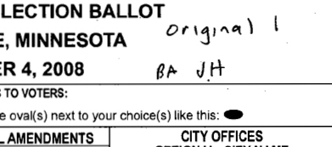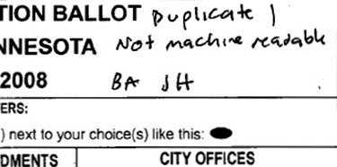
Related statutes & rules: M.S. 206.86, subd. 5; M.R. 8230.3850

Delivering Election Returns
As soon as possible, one or more judges should deliver the required election materials to your local election official. These include:
- Sets of ballot counter tapes and Summary Statements
- Sealed envelopes or containers with all voted ballots
- Sealed spoiled ballot envelope
- Sealed envelope of original ballots for which duplicates were made
- Polling place rosters
- Completed voter registration applications
- Pre-Registered and Election Day Registration Rosters
- Other materials as directed by your local election official
Related statutes & rules: M.S. 204C.27

Closing with a Central Ballot Count
Judges must complete three or more copies of the Summary Statement for state elections. Prepare at least two copies of the Summary Statement for elections not held on the same day as a state election.

Procedures at Polling Place
After the last voter inserts their ballot, compile the following statistics:

Ballot Counts
As directed by your local election official, check to see if any ballots need to be duplicated for proper scanning. Count and record:
- Total ballots delivered to your precinct, adjusted by any discrepancies in the actual count noted throughout the day in the Incident Log. Some jurisdictions may provide a separate tracking form.
- Unofficial ballots, if any.
- Spoiled ballots.
- Unused ballots.
- Total ballots being returned.
- If instructed, any write-in votes.

Roster & Registration Counts
- Persons registered to vote in your precinct at 7 a.m. This number can be found on the back of the pre-registered roster.
- Persons who registered at the polling place. Count the voter signatures on the Election Day Registration Roster, or count voter registration applications.
- Voter signatures on the rosters (Pre-Registered Roster plus the Election Day Registration Roster) or voter receipts.
- Do not count ‘AB’ notations printed, written or stamped on the registered roster.

Deliver the Ballots to Counting Center
Seal the ballots in the ballot box, container or transfer case and sign the certification. At least two judges from different major political parties must take the ballot box and the certification forms to the courthouse or counting center.
Related statutes & rules: M.R. 8230.2250

At the Counting Center
At the counting center or the local collection point, you will either deliver the ballots to another team of judges or stay with the ballots while they are counted. After counting, the judges in charge of the ballots certify the results and complete the precinct Summary Statement.

Counting Steps
- Verify the seal on the ballot container. Open the container, remove the ballots and run them through the ballot counter.
- For large precincts the ballots may need to be run in two or three batches. Avoid mixing counted ballots with uncounted ballots.
- As directed, make duplicates of ballots sorted out during counting. See instructions on ballot duplication in this guide.
- If directed by your local election official, count write-in votes and record the names and vote totals on the Write-in Tally Sheet. Examine all ballots by hand for write-in votes, not just those ballots the ballot counter sorted as write-ins (The ballot counter will miss write-in votes if the voter did not fill in the write-in oval).
- After ballots are counted, the operator will print a Summary Statement with the totals.
- Compare these totals to the number of voted ballots and the number of people who voted; if the totals do not match, resolve the problem with your local election official. When totals match and/or any problems have been resolved, complete all statistics using data from your polling place certification forms and sign the Summary Statements.
- Seal the ballots and sign the certificate or seals on the ballot container or envelope.

Election Returns
Turn the election returns over to your local election official, including:
- Sets of ballot counter tapes or Summary Statements.
- Sealed envelopes or containers with all voted ballots.
- Sealed spoiled ballot envelope.
- Sealed envelope of original ballots for which duplicates were made.
- Polling place rosters.
- Completed voter registration applications
- Pre-Registered and Election Day Registration Rosters.
- Other materials as directed by your local election official.
Related statutes & rules: M.S. 204C.27

Hand-Count Precincts
This section contains procedures that are specific to precincts that do not use a precinct ballot counter or central count but are counted by hand.

Opening Procedures

Lock the Ballot Box
In hand-counted precincts, one judge locks the ballot box and gives the key to another judge. The ballot box remains locked throughout the day until the ballots are counted. A numbered seal can be used in place of a lock.

Closing the Polls
- Begin counting immediately after the last voter finishes.
- Continue counting without interruption, except to recess for meals or short breaks, until finished.
- Only election judges may handle ballots and other election materials. A separate set of judges may be appointed to count ballots. If so, they take the judges’ oath when reporting to the polling place.
- The election judges on each counting team shall be evenly divided between the major political parties.
- During closing you will:
- Complete the Summary Statement.
- Count the number of ballots per box.
- Count the total number of ballots.
- Count the number of votes.
- Follow the laws for determining voter’s intent found in this guide.
Related statutes & rules: M.S. 204C.19, subd. 1 & 2; 204B.22, subd. 2

Summary Statements
- For state elections, there will be at least three copies of the Summary Statement in the supplies. Complete the Summary Statements as you count the ballots.
- Ensure the Summary Statements are accurate and complete. Check that the Summary Statements have the correct:
- Precinct
- City/Township name
- Date and election type (state primary, state general, special election, etc.)
- Offices and candidates for each office.
Related statutes & rules: M.S. 204C.26, subd. 2

State Primary
The Summary Statements for state primary elections will have separate parts for each political party and a separate part for nonpartisan candidates. Write-in votes are not allowed for primary elections.

State General Election
On Write-In Tally Sheets for general elections, you will record the names of registered federal, state and county write-in candidates and the votes each received. Write-in votes for local municipal, school district and hospital district candidates must always be tallied. Your local election official will tell you if you need to tally these votes at the polling place.

Count the Ballots
- Remove all the ballots from the ballot box.
- If two ballots of the same kind are folded together, set them both aside until all the ballots in the box have been counted; if it is clear that both ballots were from the same voter, set them aside and do not count them yet.
- Count the ballots into cross-stacked individual piles of 25 and add up the piles to determine the total number of ballots in the ballot box.
Related statutes & rules: M.S. 204C.19, subd. 2; 204C.20, subd. 1

Ballot Accounting
Account for all ballots by adding:
- The number of voters who voted;
- The number of spoiled ballots; and
- The number of unused ballots.
The total should equal the number of ballots issued to the polling place. Compare the number of ballots in the ballot box to the number of people who voted. It should be equal to or less than the number of voters and not more. If there are more, proceed with the section below.

Excess Ballots in the Ballot Box
- If a pair of ballots is folded together and it appears one voter submitted them both, fold them back together as found and set them aside. Evaluate if this accounts for the excess ballots in the ballot box.
- If there are still too many ballots, set aside any ballots that do not have judges’ initials on them. Evaluate if this accounts for the excess ballots in the ballot box.
- If there are still excess ballots, place the remaining ballots back in the box and have one judge randomly take out ballots until the remaining ballots equal the number of voters. Keep all the set-aside ballots together and attach a note explaining why they were removed and not counted.
- Once the number of ballots and voters is balanced, seal any set-aside or excess ballots, along with any relevant explanatory notes, in a separate envelope. Contact your local election official immediately if you have any confusion or doubts on this process. For your reference, this procedure can be found in M.S. 204C.20, subds. 1-4.

Determining Voter Intent
Minnesota law requires that every effort be made to accurately count all votes on a ballot. Never reject a ballot for a technicality if it is possible to decide what the voter intended, even if the voter made a mistake or damaged the ballot. Count only those offices for which you can decide voter intent, using these rules:
- A ballot may be marked with a pencil or a pen or both.
- Voter marked too many candidates for the same office, including write-in candidates. Do not count any of the votes for that office but count the rest of the ballot.
- Voter voted both ‘Yes’ and ‘No’ on a question. Do not count any of the votes for that question but count the rest of the ballot.
- Two candidates were marked, and the ballot shows the voter tried to erase one of the marks. Count the vote for the remaining marked candidate.
- Voter wrote a write-in candidate in the proper place on a general election ballot but did not fill in the mark. Count the vote. Remember, write-in votes are not allowed in primary elections
- A write-in vote was misspelled or abbreviated. Count the vote if the intended candidate’s identity is clear. An oval by the write-in line need not be marked to be counted.
- Voter voted for candidates from more than one party in a primary election. Voter intent cannot be determined, so the entire partisan portion of the ballot is defective. Do not count any of the partisan votes on the ballot.
- Two or more persons are to be elected to an office, but the voter did not choose the maximum number allowed. Count only those that are marked.
- Voter wrote an identification number or signed their name anywhere on the ballot; or wrote someone else’s name on the ballot completely outside of a write-in space. The voter has identified the ballot and the entire ballot is defective. Do not count any of the votes on the ballot.
- Voter used a mark other than filling the oval, but the intention is clear. Count the votes for each candidate. If the voter used two or more different marks, for example an ‘x’ and a checkmark, count the votes unless it is evident the voter intended to make the ballot identifiable.
- Ballot has extraneous marks outside the ovals. Count the ballot.
- Ballot is slightly soiled. Count the ballot.
- Voter’s mark is outside of the oval, but on or so near a name or space that it is clear the voter intended to mark the name. Count the vote.
Related statutes & rules: M.S. 204C.22

Defective Ballots
For hand-counting, a ballot is completely defective if you cannot decide the voter’s intent for any of the offices or questions on the ballot; or, the voter wrote a name on the ballot completely outside of a write-in space, signed their name or wrote an identification number on the ballot.
Print ‘Defective’ on the back of the ballot. If only part is defective, print ‘Defective as to …’ and the office or question for which the vote is defective. Keep defective ballots with the other voted ballots.
Write the number of totally and partially defective ballots on the Summary Statement.
Related statutes & rules: M.S. 204C.22; 204C.23; 204C.24

Counting the Votes
After resolving the number of ballots to be counted, count the votes on the ballots:
- Start with the first office or question on the ballot, separating the ballots into these piles:
- Each candidate (including write-ins) or question.
- Ballots that are blank for that office (undervoted).
- Ballots that are defective for that office (overvoted).
- Set aside any ballots that are totally blank or totally defective.
- After sorting all ballots into piles, count them into individual cross-stacks of 25. Add up the stacks and announce the totals when you finish.
- Repeat this procedure until all offices or questions have been counted.

Completing Summary Statements
When finished, all judges who counted ballots must complete and sign the Summary Statement. Include the following:
- Number of ballots delivered to your precinct as adjusted by actual counts.
- Number of unofficial ballots made, spoiled ballots and unused ballots.
- Number of persons registered at 7 a.m.
- Number of persons who registered to vote on Election Day.
- Number of signatures on the registered roster.
- Number of voted ballots being returned for your precinct.
Place a full set of completed Summary Statements in each envelope. Sign the Summary Statement envelopes over the flaps. All forms should be completed and signed before any judge leaves.
Related statutes & rules: M.S. 204C.26, subd. 2

Delivering Election Returns
As soon as possible, one or more judges deliver the required election materials to your local election official. These include:
- Sets of Summary Statements.
- Sealed envelopes or containers with all voted ballots.
- Sealed spoiled ballot envelope.
- Polling place rosters.
- Completed voter registration applications, Election Day rosters.
- Other election materials (as directed by your local election official).
Related statutes & rules: M.S. 204C.27

Head Judge
The Head Judge is the lead election official in the polling place and has completed one additional hour of required training for handling some of the more complex duties. You oversee the polling place; assign judges to specific tasks and give others direction as needed. You also:

- Pick up the precinct supplies before the election.
- Ensure supplies are ready before opening.
- Oversee polling place setup.
- Administer the election judge oath.
- Conduct emergency judge training for replacement judges (see below).
- Resolve questions and problems during Election Day.
- Complete election returns and other forms.
- Closes the polling place and returns materials.
Relates statues & rules: M.S. 204B.20; M.R. 8240.1750

Emergency Preparedness
If a fire, a weather emergency, or another type of emergency occurs during voting hours, take steps to protect yourself and the other people in the polling place. Familiarize yourself with evacuation plans for the polling place. Do not worry about election supplies until after everyone in the polling place is safe.

Change of Polling Place
Contact your local election official if your polling place is unusable and you must move to a new polling place. Upon their approval, a location may be used which is as near as possible to the original polling place. Publicly announce the change to the voters present and post a notice in a location visible by voters from their motor vehicles. Post a similar notice of the change in the new polling place.
Related statutes & rules: M.S. 204B.17

Replacing an Absent Judge
Head election judges are responsible for training replacement election judges appointed on Election Day. Head Judges should follow the emergency training checklist provided by the county auditor to conduct this training.
Related statutes & rules: M.S. 204B.23

Emergency Judge Training
You are responsible for training replacement judges appointed on Election Day. Follow the emergency training checklist provided by the county auditor to conduct this training.

Emergency Voting Procedure
If a voter’s name was erroneously left off the roster and the person refuses or is unable to complete the Election Day registration procedure, follow this emergency voting procedure.
- Contact the county auditor to ensure that the person is registered.
- If the auditor confirms the registration and authorizes you to do so, have the voter print the required name and address information on the roster page where the voter would have been listed alphabetically.
- Two judges note on the roster that the voter was permitted to vote pursuant to instructions from the county auditor.
- Two judges initial the voter’s entry on the roster.
- Give the voter a receipt and direct the voter to the Demonstration or Ballot Judge.
- Make a note in the Incident Log.
Related statutes & rules: M.R. 8200.3800

Incident Log
- Instruct all judges to record any unusual events or problems in the Incident Log. For example, if a ballot counter stops operating, a disturbance has occurred in the polling place, a voter’s name is missing from the roster or if a voter is upset about something that happened in the polling place, etc., record this information, the time the event occurred and the resolution in the Incident Log.
- Remind judges that the Incident Log is key to solving problems at the end of the day. Ballots and signatures don’t match? Check Incident Log to find clues.
- Include as much detail as possible in case further investigation becomes necessary. Return the Incident Log to your local election official along with the other precinct supplies.
- The following events and information must be recorded in the Incident Log (if they occur).
  - Discrepancies in ballot counts (204C.09)
  - Ballots found in voting station (8230.1050)
  - Facts surrounding excess ballots (8230.2030)
  - Opening a ballot box during voting hours (8230.4365)
  - Irregularities or discrepancies with the ballot counter seal (8230.4365)

Absentee Ballots
The roster notation ‘A.B.’ next to a voter’s name indicates the voter has cast an absentee ballot. The voter cannot vote in the polling place. Your local election official may provide you with a supplemental list of voters who voted by absentee ballot after the rosters were printed. Print ‘A.B.’ on the appropriate signature line of the roster for the voters that appear on this list.
Your local election official may also contact you on Election Day to determine whether voters whose absentee ballots were received have already voted in person. By phone, you may be asked to immediately print ‘A.B.’ on the appropriate signature line so these ballots may be accepted and counted. Alternatively, you may receive an updated supplemental list and be asked to confirm with your election official when the appropriate signature lines have been marked.
Related statutes & rules: M.S. 203B.121

Health Care Facility Judges
Health care facility judges are designated by local election officials or the county election office. Certified election judges are required to attend an additional hour of training to be able to conduct health care facility absentee voting.
Ballots are delivered only to an eligible voter who is a temporary or permanent resident or patient in a health care facility or hospital located in the municipality in which the voter maintains residence and has completed an absentee ballot application.
The ballots are delivered by two election judges affiliated with different major political parties. When the election judges deliver or return ballots, they are required to travel together in the same vehicle. Both election judges shall be present when an applicant completes the certificate of eligibility and marks the absentee ballots.
The health care facility voter has a choice to:
- Mark their own ballot
- Use the assistance of the health care facility judges in marking their ballot
- Request the assistance of another person who is not an agent of their employer or union to mark their ballot
- There is no limit on how many voters a health care election judge team can assist to mark ballots
The voter must provide consent to allow for the health care facility judges to provide ballot marking assistance.
Most of the health care facility outreach voting occurs during the 20 days preceding an election.

“Election Day” Health Care Facility Voting
On a rare occasion, election judges might provide health care facility voting on Election Day. They only deliver absentee ballots to an eligible voter who became a resident or patient in a health care facility or hospital one day before the election in the municipality of their residence. The voter is required to have requested an absentee ballot application from the local election official or the county election’s office by 5:00 p.m. the day before the election.
Most voters who become a resident or patient of a health care facility or hospital the day before the election choose to use agent (not election judge) delivery procedures for absentee voting on Election Day.
Related statutes & rules: M.S. 203B.11; M.S. 203B.04

Appendix

Head Judge Duties Checklist

Opening
- All judges report to assigned precinct one hour prior to start of voting hours. Generally, voting hours start at 7a.m., but may differ in certain circumstances. Call your local election official if all judges have not arrived. Request assignment of replacement judge(s).
- All judges take the judge oath, sign the Judge Oath Form, and receive badges.
- Assign judges to set up the polling place, post posters and signs and post the U.S. flag outside the building where the polling place is located.
- Assign judge duties (Greeter, Roster, Registration, Demonstration, Ballot and Ballot Counter) and give them directions.
- If you received a list of absentee voters, mark the names on the roster with ‘A.B.’.
- If you received a list of election day registration absentee voters, provide to Roster Judge.

Ballot Box Opening
- Open all doors on the ballot box, remove all contents of the ballot box, have all judges confirm box is empty, then relock or seal the ballot box. Similarly, confirm that any auxiliary ballot boxes are empty.
- Two judges check ballots against the official certification form to make sure they are the correct precinct.
- Certify the correct number of ballots were delivered to the precinct, count ballot packs.
- Two judges begin opening ballot packs, counting number of ballots in each pack, recording any discrepancies on Incident Log and initialing ballots.
- Place ballots in view of judges in a secure area.

Ballot Counter & Ballot Marking Station Setup
- Place ballot counter on the ballot box.
- Two judges check seal number of the ballot counter against the official certification form, complete and sign form. Plug ballot counter into electric outlet.
- Run the ‘zero’ tape.
- Check precinct number indicated on the ‘zero tape’ to confirm it is your precinct.
- Check an actual ballot against the tape output – must be in same rotation.
- Confirm vote total column reads 0000 – all zeroes.
- After tape stops, do not tear off tape but secure it as one continuous tape and the ballot counter is ready for voting.
- Set up ballot marking station in accessible area where it will not be confused for the ballot counter.
- Verify ballot marking device displays correct information for the precinct

Open Polls
- Judges begin their assigned duties, announce that the poll is open. If the ballot counter is not operating, use the auxiliary ballot box for deposit of ballots until the ballot counter is operating.

Close Polls
- Announce that the poll is closed at 8 p.m. Voters waiting in line at 8pm are allowed to vote. After last voter has voted, the public is allowed to view the counting process.

Closing with a Ballot Counter
- Inspect seal on the ballot counter, confirm the seals are still intact.
- Print required number of sets of tapes (local election official will instruct).
- Complete all blank lines on the Summary Statement on the ballot counter tapes and complete any additional Summary Statement forms provided by your local election official.
- If the total number of voters does not equal the number of votes cast, contact your local election official.
- If ballot counter is equipped with a modem, transmit results to headquarters.
- All judges sign all tapes.
- Place all tapes with election materials for return.
- Turn off and unplug ballot counter, cut seal on ballot counter, remove memory card
and place in protective cover or bag.
- Place the memory card with materials for return.

Central Count Closing Procedures
- Reseal the ballots in the ballot box and sign the certification.
- At least two judges of different major political parties take the ballot box and Summary Statements to the central count location.

Voters’ Bill of Rights
From Minnesota Statutes 204C.08, subd. 1d (https://www.revisor.mn.gov/statutes/cite/204C.08).
For all persons residing in this state who meet federal voting eligibility requirements:
- You have the right to be absent from work for the purpose of voting in a state, federal or regularly scheduled election without reduction to your pay, personal leave, or vacation time on election day for the time necessary to appear at your polling place, cast a ballot and return to work.
- If you are in line at your polling place any time before 8:00 p.m., you have the right to vote.
- If you can provide the required proof of residence, you have the right to register to vote and to vote on election day.
- If you are unable to sign your name, you have the right to orally confirm your identity with an election judge and to direct another person to sign your name for you.
- You have the right to request special assistance when voting.
- If you need assistance, you may be accompanied into the voting booth by a person of your choice, except by an agent of your employer or union.
- You have the right to bring your minor children into the polling place and into the voting booth with you.
- If you have been convicted of a felony but your felony sentence has expired (been completed) or you have been discharged from your sentence, you have the right to vote.
- If you are under a guardianship, you have the right to vote, unless the court order revokes your right to vote.
- You have the right to vote without anyone in the polling place trying to influence your vote.
- If you make a mistake or spoil your ballot before it is submitted, you have the right to receive a replacement ballot and vote.
- You have the right to file a written complaint at your polling place if you are dissatisfied with the way an election is being run.
- You have the right to take a sample ballot into the voting booth with you.
- You have the right to take a copy of this Voters’ Bill of Rights into the voting booth with you.

Voter Registration Application
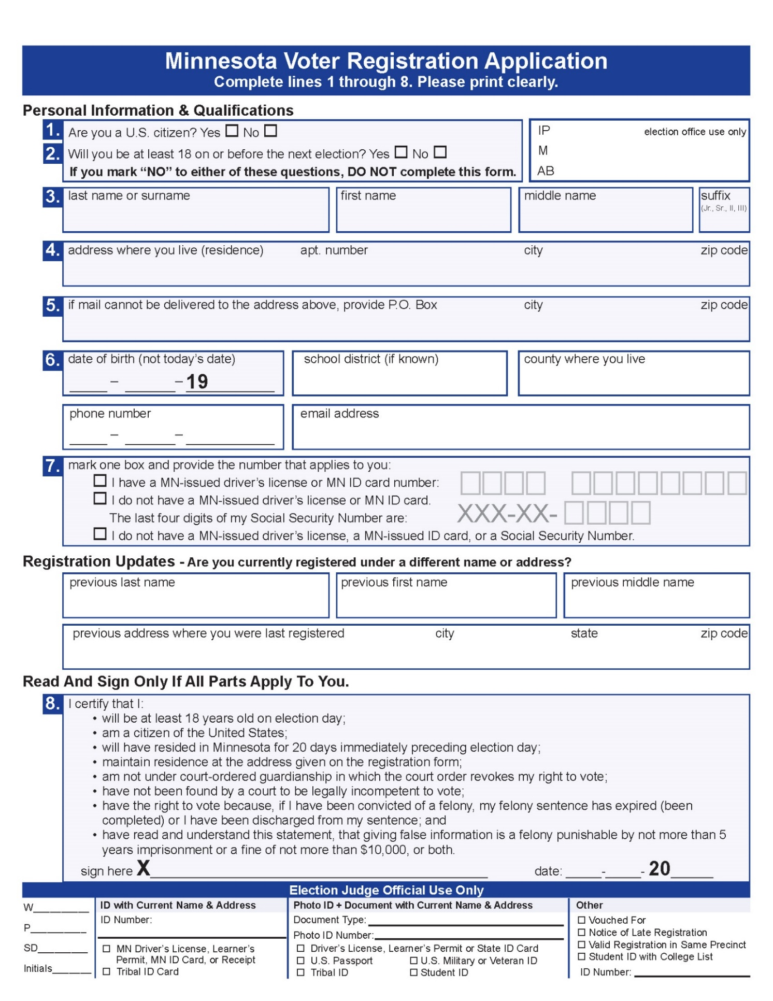

Voucher Form
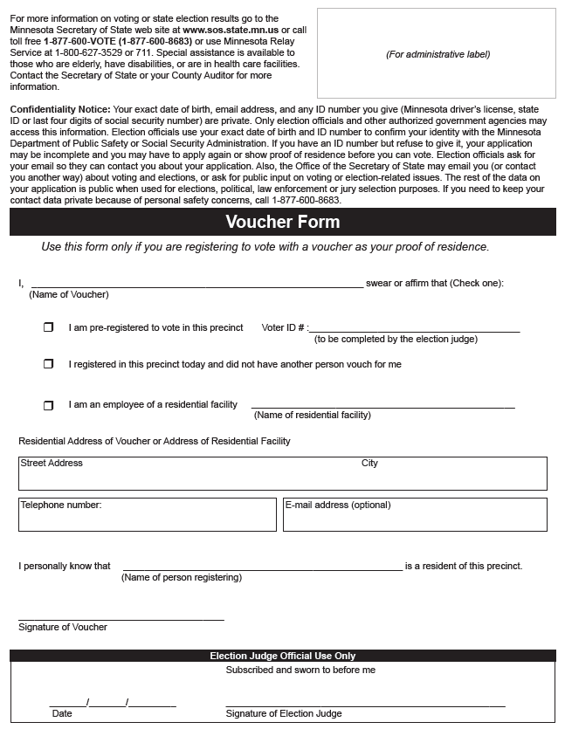

Guide for Registration Application

Required Sections
- Sections 1 & 2: Qualifications Check Boxes—voter checks the box whether they are a U.S. Citizen & 18 years of age.
- Section 2: Voter Name—voters give their last name or surname, first name, middle name, and suffix (if suffix applies).
- Section 4: Home Address—voters print the street address or a geographical description of where they live. An example of a geographic address is ‘Highway 47, ½ mile north of County Road E.’A business address may not be used, unless it is also the voter’s home. Neither a U.S. Post Office Box, nor its commercial equivalent may be used as a residential address.
- Section 6: Date of Birth—voters give their complete date of birth.
- Section 7: Identification Check Boxes— voters check the box that applies to them and fill in the respective ID number. If the voter does not have a MN-issued driver’s license, a MN-issued ID card, or a Social Security number, they check the third box.
- Section 8: Oath, Signature & Date—be sure to tell voters to read the oath on the application and sign only if all parts apply to them. By signing, they affirm that all the statements on the application are true and correct and that they meet the requirements in the certification. Giving false information to register to vote is a felony punishable by up to 5 years in prison and/or a fine up to $10,000.

Complete if Applicable/Possible
- Section 5: Mailing Address—give a mailing address (such as a PO Box) only when the U.S. Post Office will not deliver mail to the voter’s actual street or geographical address. Other mailing addresses such as a workplace address cannot be used.
- Section 6: Line Phone Number—encourage voters to list their phone number so they can be contacted if there is difficulty in processing the application, although it is okay if they do not.
- Section 6: School District & County—if voters are sure of their school district, have them indicate the district number or name; otherwise leave blank. If there is a school district election on the ballot, use the precinct finder to verify the voter’s school district.
- Section 6: Email Address—voters may provide their email address, although it is acceptable if they do not.
- Registration Updates—voters can provide previous name or address information to indicate if they are currently registered to vote under a different name or at a different address; these voters complete a new VRA, even if they reside in the same apartment complex but only change apartments. Voters should provide the name and/or address of their previous registration so their existing voter record can be found and updated. If a voter was registered to vote at a previous address or name in the same precinct, no further proof of residence is needed.

Precinct List of Persons Vouching
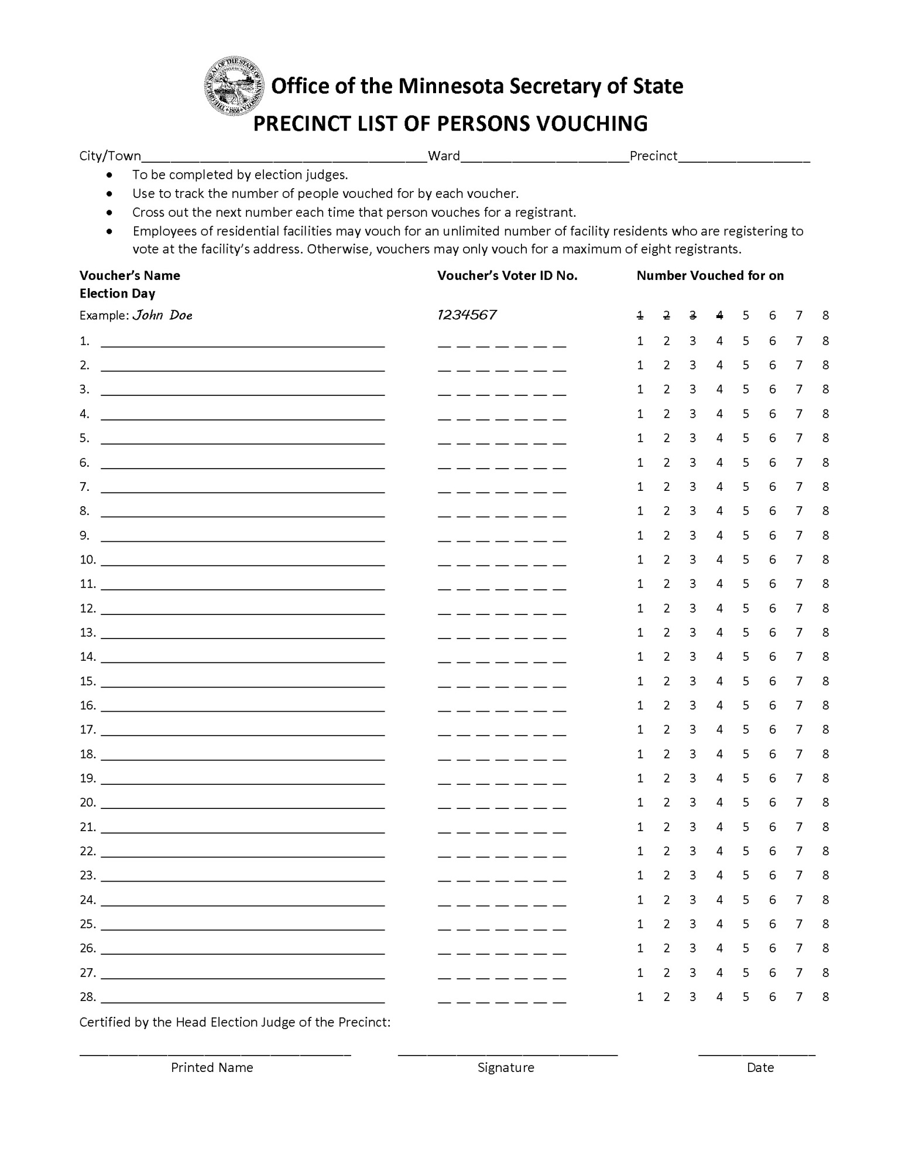

Voting Residence Laws
From Minnesota Statute 200.031 (https://www.revisor.mn.gov/statutes/cite/200.031).
Residence shall be determined in accordance with the following principles, so far as they may be applicable to the facts of the case:
- The residence of an individual is in the precinct where the individual's home is located, from which the individual has no present intention of moving and to which, whenever the individual is absent, the individual intends to return;
- An individual does not lose residence if the individual leaves home to live temporarily in another state or precinct;
- An individual does not acquire a residence in any precinct of this state if the individual is living there only temporarily, without the intention of making that precinct home;
- If an individual goes into another state or precinct with the intention of making it home or files an affidavit of residence there for election purposes, the individual loses residence in the former precinct;
- If an individual moves to another state with the intention of living there for an indefinite period, the individual loses residence in this state, notwithstanding any intention to return at some indefinite future time;
- Except as otherwise provided in this section, an individual's residence is located in the precinct where the individual's family lives, unless the individual's family is living in that precinct only temporarily;
- If an individual's family lives in one precinct and the individual lives or does business in another, the individual's residence is located in the precinct where the individual's family lives, unless the individual establishes a home in the other precinct and intends to remain there, with or without the individual's family;
- The residence of a single individual is in the precinct where the individual lives and usually sleeps;
- The mere intention to acquire a new residence, is not sufficient to acquire a new residence, unless the individual moves to that location; moving to a new location is not sufficient to acquire a new residence unless the individual intends to remain there;
- The residence of an individual who is working temporarily in any precinct of this state is in the precinct where the individual's permanent home is located;
- The residence of an individual who is living permanently in a soldiers' home or nursing home is in the precinct where the home is located;
- If an individual's home lies in more than one precinct or political subdivision, the residence of the individual is in the precinct in which a majority of the room in which the individual usually sleeps is located;
- If an individual's home is destroyed or rendered uninhabitable by fire or natural disaster, the individual does not lose residence in the precinct where the home is located if the individual intends to return to the home when it is reconstructed or made habitable.

Oath of Challenge to Eligibility
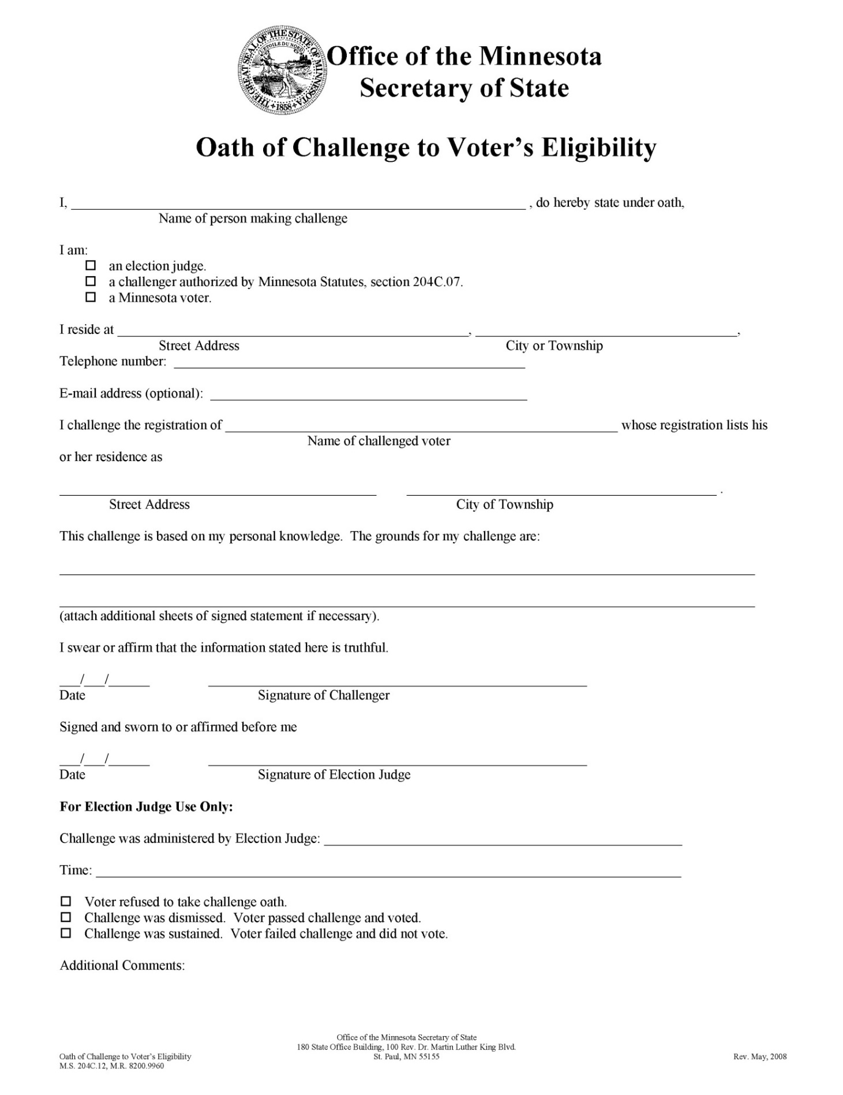

Certificate of Registered Voter
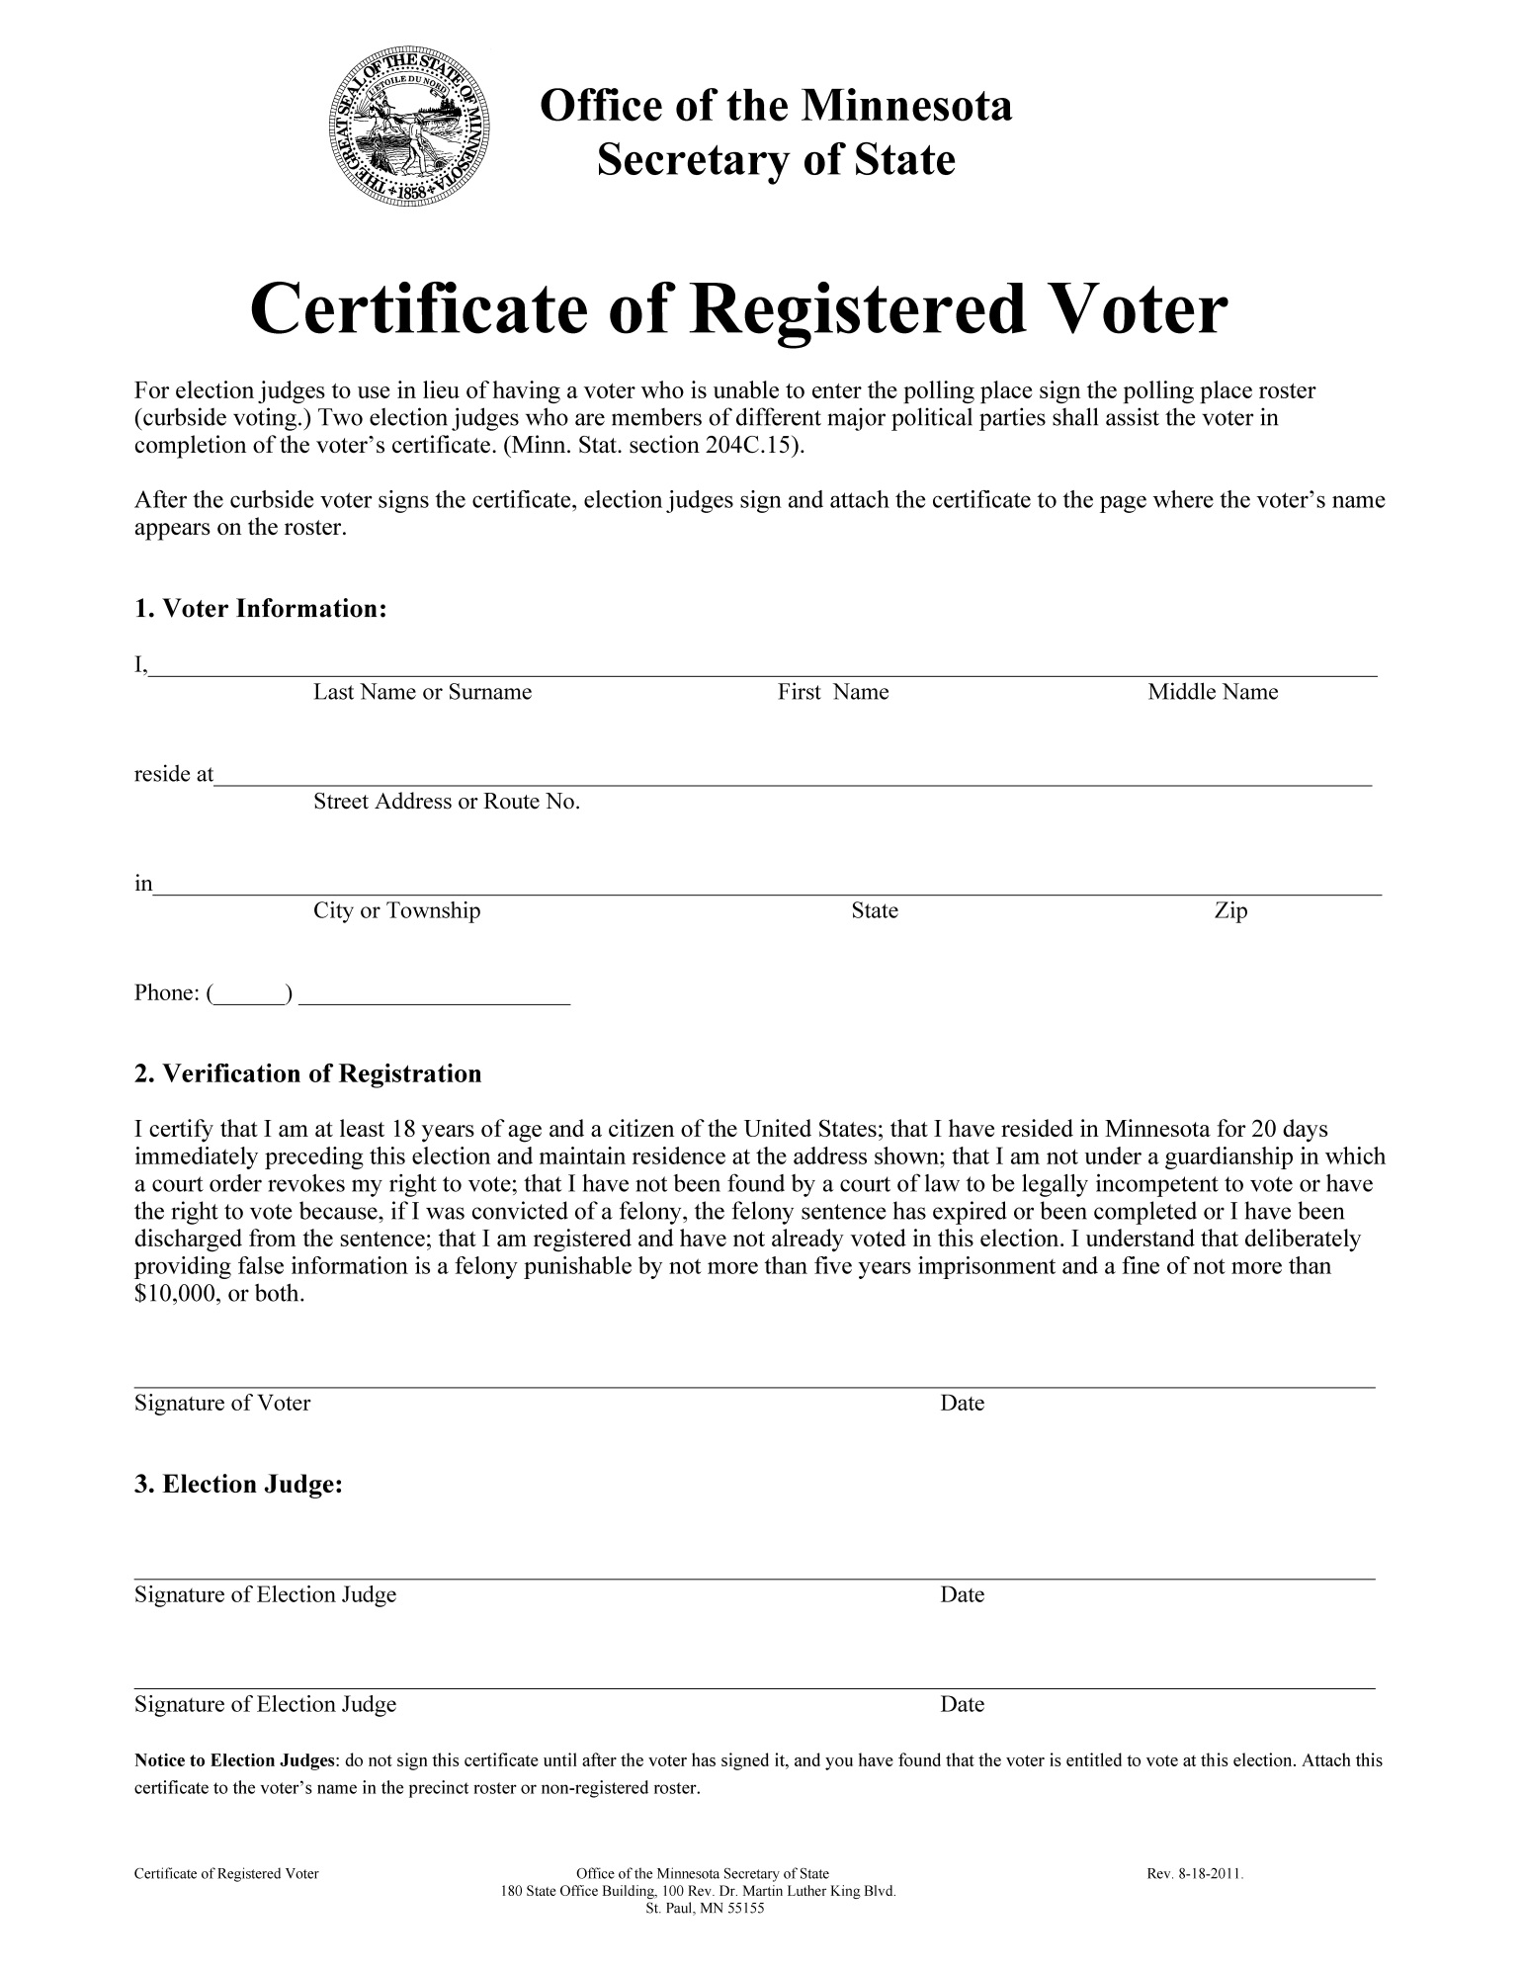

Precinct Summary Statement
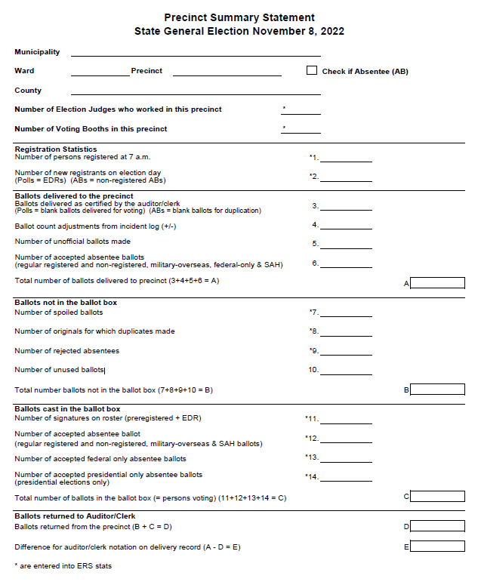
Precinct Summary Statement Page 2
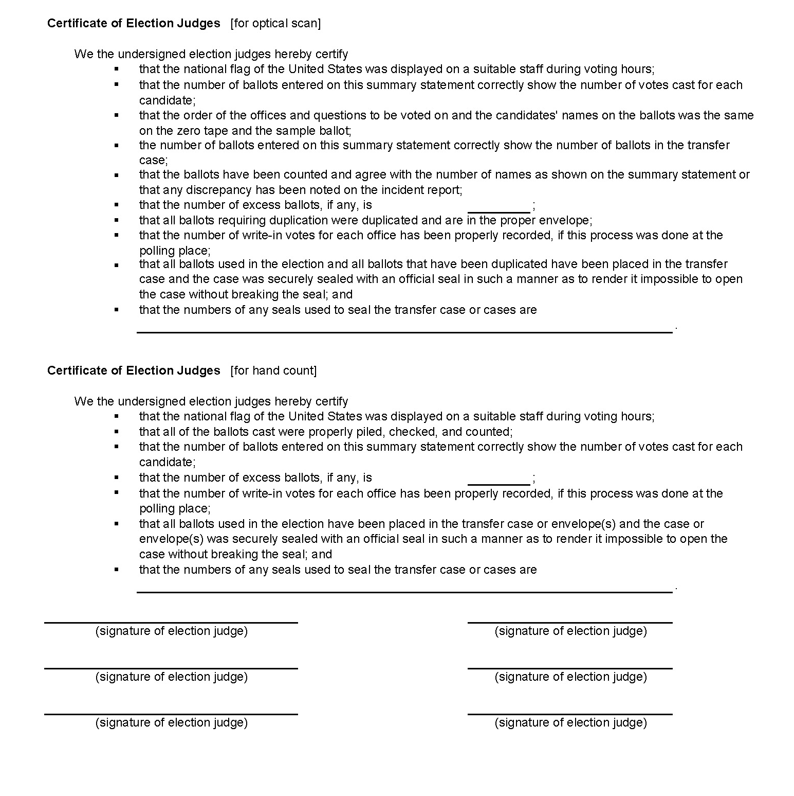

HAVA Elections Complaint Form
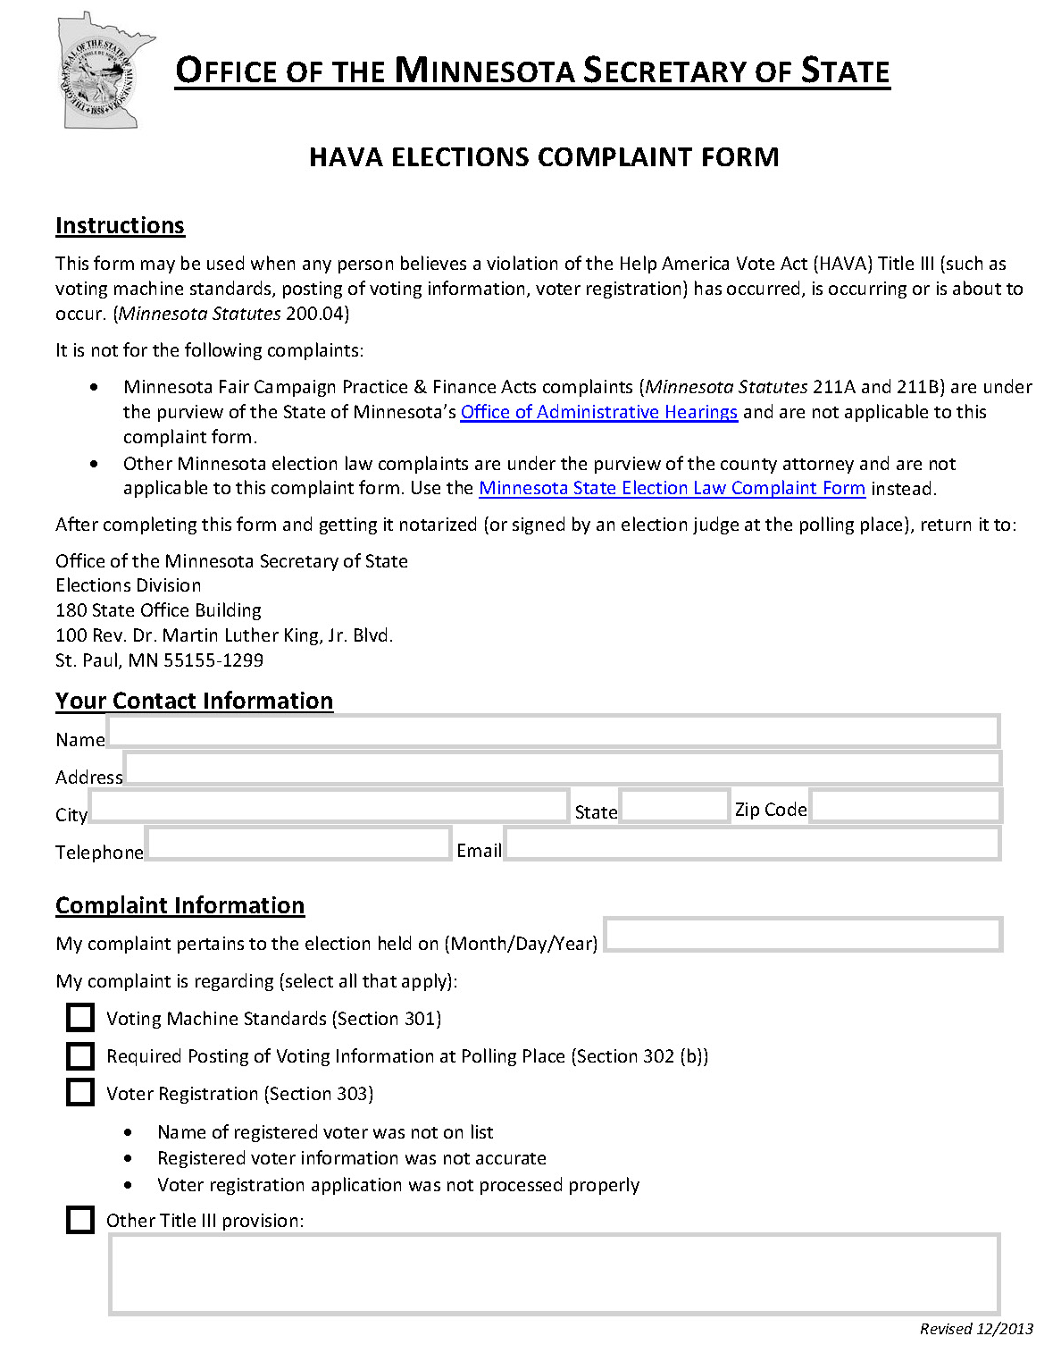
HAVA Elections Complaint Page 2
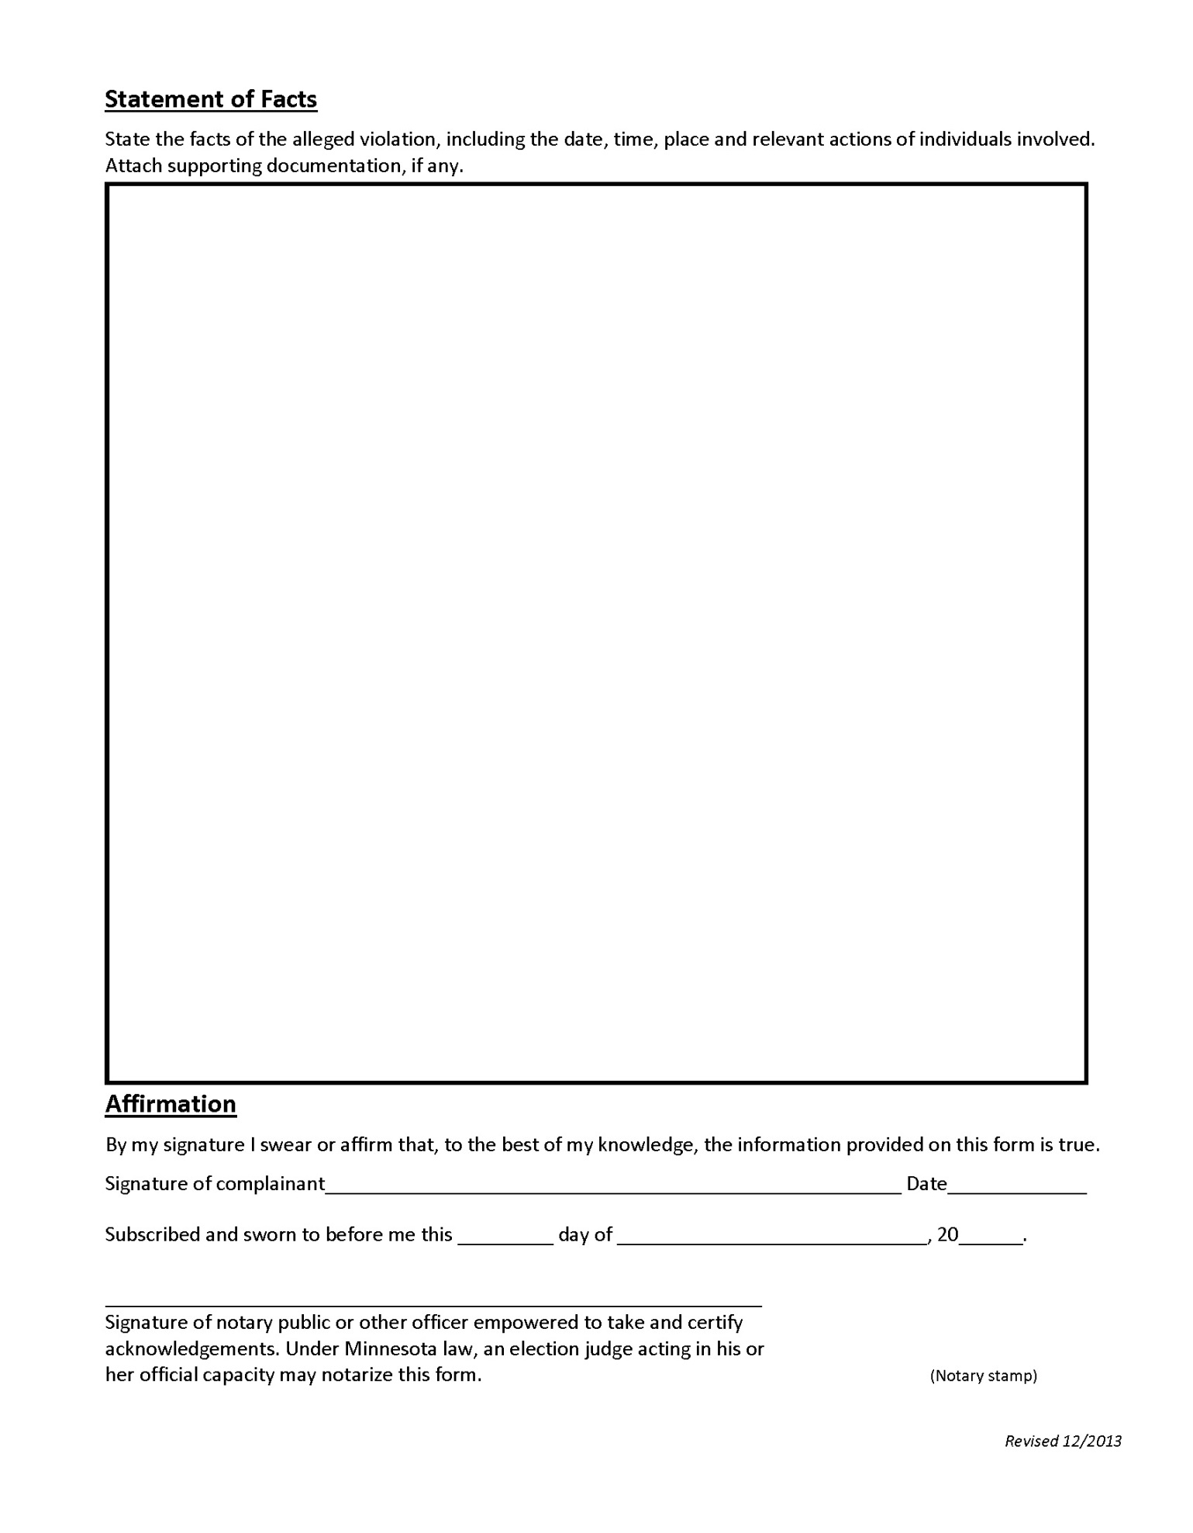

State Election Law Complaint Form
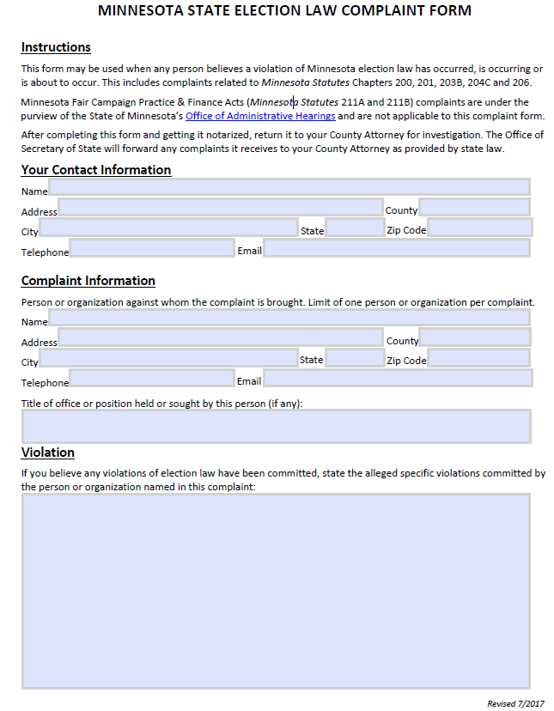
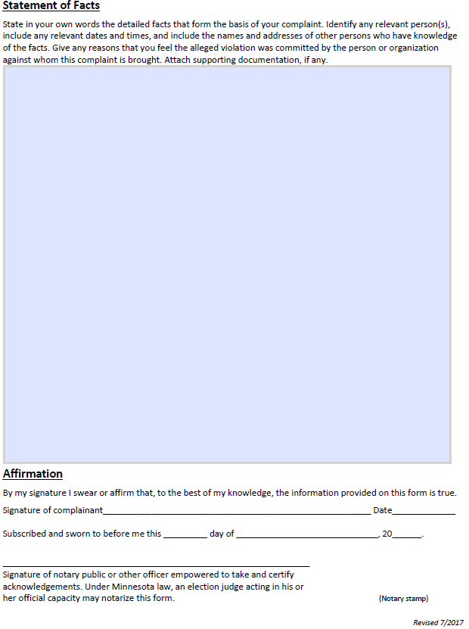

Important Contact Information

Clerk’s Office______________________________________________________________________
County Auditor’s Office ___________________________________________________________
Voting Machine Repair____________________________________________________________
County Sheriff / Local Police_______________________________________________________
Fire Department__________________________________________________________________
Emergency Medical Services ________________________________________________________
2022 Minnesota Election Judge Guide
Office of the Minnesota Secretary of State
Updated 9/7/2022

